GISFI TR SIG.103 V1.0. 0 (2013-03)

Technical Report

Global ICT Standardisation Forum for India

Special Interest Group

Wireless Robotics

(Release 1)



The present document has been developed within GISFI and may be further elaborated for the purposes of GISFI.

Keywords

<keyword[, keyword]>

***GISFI***

Postal address

GISFI office address

Address

Tel.: +91 xxxxxxx Fax: +91 xxxxxx

Internet

http://www.gisfi.org

***Copyright Notification***

No part may be reproduced except as authorized by written permission.  
The copyright and the foregoing restriction extend to reproduction in all media.

© 2013, GISFI

All rights reserved.

Contents

Foreword 4

Introduction 4

1 Scope 4

2 References 5

3 Definitions, symbols and abbreviations 6

3.1 Definitions 6

3.2 Symbols 6

3.3 Abbreviations 6

4 Wireless Robotics 7

5 General Requirements 8

6 Applications and Requirements 9

6.1 Industrial Automation 9

6.1.1 Requirements and Challenges 9

6.2 Home Automation 10

6.2.1 Requirements and Challenges 10

6.3 Health Care Application 10

6.3.1 Requirements and Challenges 10

6.4 Military Application 10

6.4.1 Requirements and Challenges 10

7 Communication in Wireless Robots 12

7.1 Types of Communication 12

7.1.1 Communication between Robot and Network 12

7.1.1.1 Requirements and Challenges 12

7.1.2 Communication between Robots without Network connectivity / with adhoc network connectivity 13

7.1.2.1 Requirements and Challenges 13

7.1.3 Communication between the individual components 13

7.1.3.1 Requirements and Challenges 13

7.2 Type of Navigations 14

7.2.1 Manual Teleoperated 14

7.2.2 Guarded Teleoperated 14

7.2.3 Line-following robot 14

7.2.4 Autonomously guided robot 14

7.2.5 Sliding autonomy 14

8 Standardisation Efforts 15

8.1 EUROP 15

8.2 JRA 15

9 Proposal 16

Annex <A>: <Annex title> 17

Change history 17

# Foreword

This Technical Report has been produced by GISFI.

The contents of the present document are subject to continuing work within the Technical Working Group (TWG) and may change following formal TWG approval. Should the TWG modify the contents of the present document, it will be re-released by the TWG with an identifying change of release date and an increase in version number as follows:

Version x.y.z

where:

x the first digit:

1 presented to TWG for information;

2 presented to TWG for approval;

3 or greater indicates TWG approved document under change control.

y the second digit is incremented for all changes of substance, i.e. technical enhancements, corrections, updates, etc.

z the third digit is incremented when editorial only changes have been incorporated in the document.

# Introduction

The term ``robot'' has many definitions, which includes the recent definition by ISO/FDIS 8373 as ``actuated mechanism programmable in two or more axes with a degree of autonomy, moving within its environment, to perform intended tasks'', and still evolving. The branch of technology that deals with the design, construction, operation, and application of robots is termed as ``Robotics''. More specifically, the subject of this document, ``Wireless Robotics'' deals with remotely and teleoperated autonomic robotic systems through an wireless communication network.

Wireless robotics is a young, multidisciplinary field involving knowledge from many areas, including electrical, electronic and mechanical engineering, computer, cognitive and social sciences. In this document the focus is on wireless networking aspects of robotics and we define three different types of wireless communication in robots:

1. Communication between robots and network,
2. Communication between the robots without network connectivity/ with adhoc network
3. Communication between different parts of robot

# 1 Scope

The scope of this document is to introduce the Wireless Robotics field and explore the technical challenges and requirement in different application domain such as industrial automation, home automation, healthcare application, military applications and Emergency or Human Inaccessible task application. This document also addresses the communication requirements arrived from various types of communications and navigations present in wireless robots. In the end, this document discusses the various standardisation activities by different SDOs in the wireless robotics field and brings out the proposed area for standardisation in this field by GISFI.

# 2 References

The following documents contain provisions which, through reference in this text, constitute provisions of the present document.

1. Marina Ruggieri,Ole Brun Madsen and Ramjee Prasad, "Editorial: Special Issue on Wireless RoboticsResearch and Standardization", Wireless Personal Communication (2012) 64:457-460
2. Henrik Schiøler and Thomas Skjødeberg Toftegaard, ''Wireless Communication in Mobile Robotics a Case for Standardization'', Wireless Personal Communication (2012) 64:583-596
3. Sanil Pruthi, ''Wireless Robotics: A History, an Overview, and the Need for Standardization'', Wireless Personal Communication (2012) 64:597-609
4. Alois Knoll and Ramjee Prasad, ''Wireless Robotics: A Highly Promising Case for Standardization'', Wireless Personal Communication (2012) 64:611-617
5. Robotics Socity of India : http://www.rsindia.org/
6. ISO : http://www.iso.org
7. Japan Robot Association : http://www.jara.jp/e/

# 3 Definitions, symbols and abbreviations

## 3.1 Definitions

Definition format (Normal)

**<defined term>:** <definition>.

**example:** text used to clarify abstract rules by applying them literally.

## 3.2 Symbols

For the purposes of the present document, the following symbols apply:

Symbol format (EW)

<symbol> <Explanation>

## 3.3 Abbreviations

AGV Automated Guided Vehicles

ISO International Organization for Standardization

JRA Japan Robot Association

M2C Machine-to-Cloud

M2M Machine-to-Machine

MAC Medium Access Control

QoS Quality of Service

RSI Robotics Society of India

SDO Standard Development Orgaization

# Wireless Robotics

Wireless robotics may be visualized as an area created through the confluence of three major domains of knowledge namely: the hardware plat-forms, the software platforms and the communication platforms. In the Figure 1., it may be observed that these three domains of knowledge may further be seen as built through the building blocks of specialized technologies. It is note-worthy that though there have been numerous attempts to build specialized platforms for robotic hardware and software platforms, no major activity has been undertaken in building specialized robotic wireless communication systems..

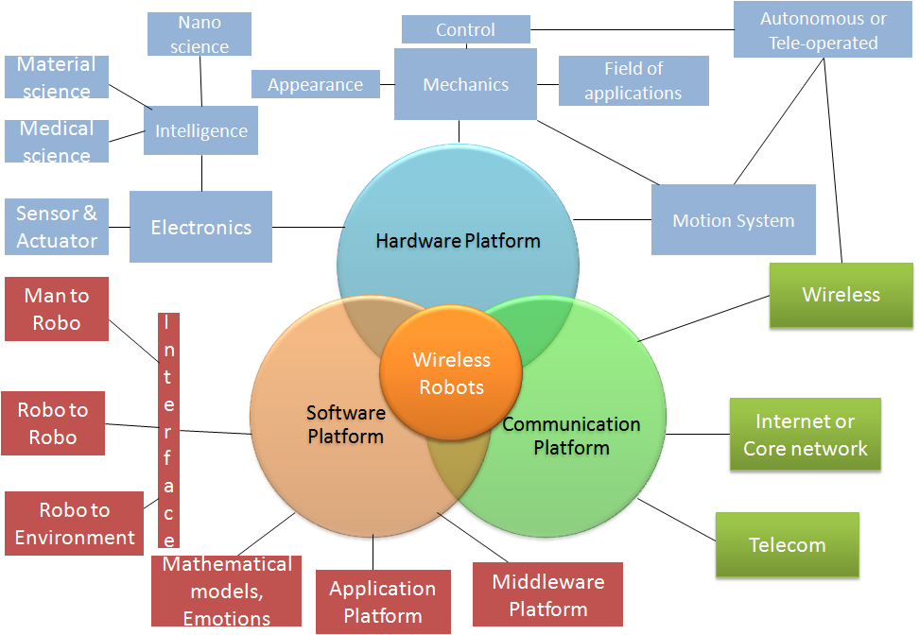

Figure 1 Wireless Robot: Platforms

# 5 General Requirements

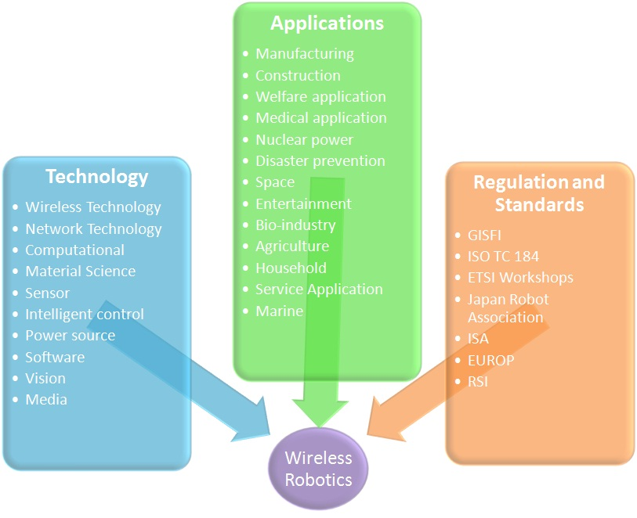

Figure 2 Wireless Robotics: Overview

Robot is an autonomous system that exists in the physical world, can sense its environment and can act on it to achieve some defined goals. Some of the possible reason robot may fail to do the assigned task, such as communication failure, communication breakdown between robots, non-cooperation among the robots, malfunctioning robots i.e one robot un-does what another robot just did or one robots thinks push while the other thinks pull or one robot refuses to help another.

As mobile robots are mainly dependent on battery power, it is important to minimize their energy consumption. In terms of wireless communication in robotics, the two concerned layers are the media access control (MAC) and network layer. The MAC layer's primary functions are to provide access control, channel assignment, and neighbor list management. It also performs power control to ensure power savings. The main principles guiding low power distributed MAC design include collisions avoidance, reduced protocol overhead, and power during idle time. First, collisions should be avoided since retransmission leads to unnecessary energy consumption and possibly unbounded delays. Secondly, protocol overhead should be reduced as much as possible, including packets dedicated for network control and header bits for data packets. Thirdly, since receivers have to be powered on at all times resulting in significant energy consumption, the more time the radio can be powered down, and the greater the power savings.

# 6 Applications and Requirements

Wireless robotics is a field where innovation from many applied engineering and technology merges together to provide best possible solution with the desired accuracy for a given engineering problem. Today there are different robots from different companies, these robots have different means for management and no communication exists between them. Since wireless robotics is a multidisciplinary field, no common standards exist which address all the requirements arrived for the different field from the different application. In this section, we discuss some of the existing or possible application fields for wireless robots, which include industrial automation, home automation, health care application, military application and emergency or human inaccessible task applications. The Figure 3 shows sample robotics product for different applications. In the following sub-sections we discuss few of the applications of robotics.

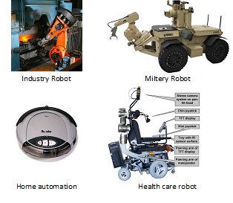

Figure 3. Sample robotics products for different application

## 6.1 Industrial Automation

An industrial robot is defined by International Organization for Standardization (ISO) as an automatically controlled, reprogrammable, multipurpose manipulator programmable in three or more axes. The field of robotics may be more practically defined as the study, design and use of robot systems for manufacturing (a top-level definition relying on the prior definition of robot). Typical applications of robots include welding, painting, assembly, pick and place (such as packaging, palletizing and SMT), product inspection, and testing; all accomplished with high endurance, speed, and precision.

### 6.1.1 Requirements and Challenges

The key technology challenges related to industrial robot automation are considered at three levels: i. Basic technologies, ii. Robot components and iii. Systems integration

i. Basic technologies: The challenge in this area is mainly related to the development of intelligent robotic assistants. The key concern here is the desired intelligent system behavior and underlying functionality such as perception, decision making, real time physical action, system architecture, learning, and use of natural language and dialogues.

ii. Robot components: Industrial robots have always depended on the availability of key components such as actuators, sensors, materials and human computer interfaces as enablers for novel systems and applications. Besides component functionality and performance, aspects of mechanical, electrical and informational integration within standard system architectures are of increasing importance.

iii. Systems integration: The main challenges lie in the development of methods and tools for instructing and synchronizing the operation of a group of cooperative robots at the shop-floor. The introduction of wireless techniques on the shop-floor; mobile work-cells involving mobile robots and manufacturing equipment for a swift change-over of manufacturing lines to new production needs; and, the establishment of a life-cycle-oriented approach of production equipment (procurement, finance, planning).

## 6.2 Home Automation

A domestic robot is a robot used for household chores. Thus far, there are only a few models, though science fiction writers and other speculators have suggested that they could become more common in the future. In 2006, Bill Gates wrote an article for Scientific American titled "A Robot in Every Home". Many domestic robots are used for basic household chores, such as the Electrolux Trilobite, Roomba and the SLAM based Neato Robotics vacuum cleaner robot. Others are educational or entertainment robots, such as the HERO line of the 1980s or the AIBO. While most domestic robots are simplistic, some are connected to WiFi home networks or smart environments and are autonomous to a high degree.

### 6.2.1 Requirements and Challenges

Domestic robots present unique design challenges that are very different from those of industrial robots. The first challenge is a lack of predictability neither users' behavior nor the physical environment can be known before a robot is placed in a home. Thus, for mobile robots, safety can be a major concern, particularly for elderly or disabled users. For example, a robot vacuum cleaner that does not audibly announce its presence could cause an elderly user with vision loss to trip and fall. Another challenge is with regard to presenting appropriate, dynamic interaction modalities that are inclusive of all users. For example, physically disabled children may not enjoy a robotic pet that moves too quickly, whereas able bodied children may be bored by one that does not. The design of interaction modalities should also consider a robot's ability to perceive and interpret a user's behavior (e.g., affective and affect-related expressions, intentions, etc.). A third design challenge is with regard to robot appearance. Vast cultural differences exist in how people think robots ought to look and behave, and certain types of appearance may be outside the realm of their comfort.

## 6.3 Health Care Application

Robots could help in the care of the elderly and chronically ill in four main ways: i. Addressing cognitive decline; for example, reminding patients to drink, take medicine or of an appointment, ii. Enabling patients and caregivers to interact, thereby reduce the frequency of personal visits, iii. Collecting data and monitoring patients, emergencies, such as heart failure and high blood sugar levels, could be avoided and iv. Assisting people with domestic tasks many give up independent living because of arthritis. Japan’s population is the most rapidly aging in the world 30 million people, accounting for 25% of the population, are over the age of 65. It now has about 44% of the world's industrial robots and is applying that expertise to healthcare.

### 6.3.1 Requirements and Challenges

The application of robotic systems to the medical health care industry requires that we bring together a diverse set of disciplines, including the all important requirement of human compatibility. Medical robotic systems must coexist and interoperate safely and effectively within a human environment. In order to be successful in the marketplace, a medical robotic system must also be user friendly and interactive. Its value-added features often come from an application specific user interface. Building such an interface requires expertise from the health care discipline as well as from the underlying robotics and engineering disciplines. The difficulty in putting together a team of designers and developers that spans the requisite fields of knowledge needed to create a medical robotic system is one of main challenges limiting the emergence of medical robotics today.

## 6.4 Military Application

Military robots are autonomous robots or remote-controlled devices designed for military applications. Such systems are currently being researched by a number of military organizations. There have been some developments towards developing autonomous fighter jets and bombers. The use of autonomous fighters and bombers to destroy enemy targets is especially promising because of the lack of training required for robotic pilots, autonomous planes are capable of performing manoeuvres which could not otherwise be done with human pilots (due to high G-Force), plane designs do not require a life support system, and a loss of a plane does not mean a loss of a pilot. However, the largest drawback to robotics is their inability to accommodate for non-standard conditions. Advances in artificial intelligence in the near future may help to rectify this.

### 6.4.1 Requirements and Challenges

Looking from a technical point of view at the constraints using military robots are: i. Energy supply: Current battery capability is a limiting factor ii. Target Discrimination: To become autonomous implies being able for the robot to act, plan and execute its tasks based on the input from its sensors, its objectives, learning capabilities and programming. iii. Complexity of the Environment: The wars fought in this decade have not been fought on a classical battlefield in the classical sense and against classical opponents. The next generation military robots need to more autonomous and should be able to work together. For this, real-time analysis of the hostile environment and the enemy is necessary. New processing technology is needed for metadata extraction from images and video streams, sensor data, and multi-media objects. This should than be translated for the robots to execute pre-determine objectives within the ever changing frame work.

# 7 Communication in Wireless Robots

Depending on application, a wireless robot will rely on various means of communication, be it parallel, serial, synchronous and asynchronous, to achieve the assigned task objectives. In this section we discuss the communication aspects of wireless robots and have organized the section in two parts: (i) Type of Communication, where we discuss different types of communication in wireless robots to exchange the data and (ii) Modes of communication for robot navigation control.

## 7.1 Types of Communication

We envisage three categories of communication for wireless robots: (i) Communication between robots and network, (ii) Communication between robots without network connectivity/ with adhoc network connectivity and (iii) Communication within robotics components (see Figure 4).

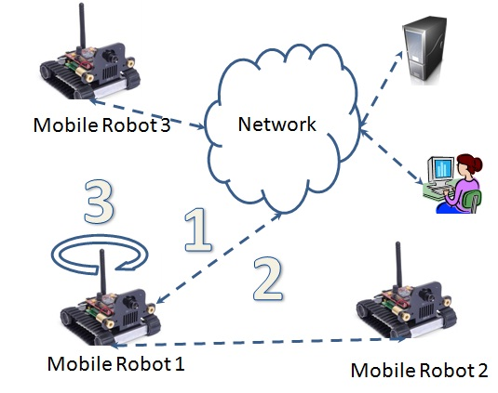

Figure 4. Communication in wireless robots

### 7.1.1 Communication between Robot and Network

Wireless robotic applications may need a disruption free communication link between the robots and the network. This is especially true in case of (a) Search and rescue scenarios and (b) Scenarios where robots have limited on-board processing (thin-robots), where proximity to the wireless network may be required to receive instructions for decision making. Thin robots can be defined as a type of wireless robot where most of the complex processing units reside in remote place, which manage and control the operations of the robots. Thin-robots bring new communication requirements and challenges.

Some of the example communication between a (mobile) robot and a fixed base station, are real-time remote control, robot access to the Internet and unidirectional video. While, the wireless base station is an important component of the networked robotics architecture, current and future research would expand the realm to cloud networking and computing scenario. The cloud enabled robotic system that leverages the combination of a virtual ad-hoc cloud formed by machine-to-machine (M2M) communications among participating robots, and an infrastructure cloud enabled by machine-to-cloud (M2C) communications with a wireless base station. The robotic systems themselves may be thin-robots with limited computational capabilities. Cloud resources are dynamically allocated from a shared resource pool, to support task offloading and information sharing in wireless robots.

#### 7.1.1.1 Requirements and Challenges

Robot controllers should be robust with respect to unpredictable and highly dynamic environment; due to the naturally hostile characteristic, controllers must also contend with imperfect wireless communication. For wireless robot category under discussion the network is also part of the robots environment and can contribute to the system's success or failure. At the simplest level, communication may succeed or fail between two nodes. Robots typically operate under strict real time constraints; fast navigation and dynamic environments require that control inputs are acquired in a timely manner. Heavy load on a wireless network increases the average data transmission time. It may reduce the performance of the controller. Reducing load by more efficient communication can decrease latency and allow robots to be more responsive to dynamic environments. Bandwidth is a precious resource if a robot's task involves transmitting huge data to a user (e.g. live video) in such case control data is unwelcome overhead on the shared communications channel. Efficiency becomes increasingly important when scaling to a large numbers of robots, which also leads to the requirement of scalability. Efficient communication is also essential to save power and reduce latency this can be achieved by considering the interaction between control and communication channel. Specialized protocols should be designed for wireless robot that takes care of deterministic communication requirements which in turn would mean usage or allotment of new licensed spectrum.

There is also a necessity to study security aspects of such category of robots which involves (i) mutual authentication between robot and network, (ii) authentication of messages being sent together with integrity protection, (iii) confidentiality protection, (iv) as robots do crucial jobs, high availability is of utmost importance and (v) secure operations and management solution.

### 7.1.2 Communication between Robots without Network connectivity / with adhoc network connectivity

Communication between robots, without network, e.g., robots communicate directly with one or a (potentially large) number of peers, when they get into transmission reach through an adhoc wireless network. This type of communication could be beneficial whenever tasks are to be performed jointly, e.g., jointly carrying a load, but also joint sensory tasks, such as distributed exploration of the environment and map building. One could consider that such category of communication also be beneficial for the category where robots have communication with the network.

#### 7.1.2.1 Requirements and Challenges

Consider a group of mobile robots that are required to autonomously disperse throughout a region, perform distributed sensing, monitoring or surveillance, and pass the sensed data to a single collection point. The robots are most likely equipped with only low power wireless transceivers whose range is too short to allow direct communication with the data collection point, but sufficient to allow robots to communicate with close neighbours. These circumstances qualify as ad hoc wireless networking scheme. Designers may not prefer a centralized system due to the design and cost consideration or could decide to use a combination of centralized and de-centralized approach.

To guarantee a certain level of Quality of Service (QoS), a centralized solution (as in the first category of communication between robot and network) expensive base stations will be required to cover the service area together with complex system management that increases the total cost of a system. On the other hand, for given scenarios, decentralized and distributed systems based on local interactions among autonomous robots could support ad-hoc changes in population, connectivity and local constraints. They could show robustness to local failures and scale well. In unpredictable or unplanned environments mobile robots need to create a wireless network to cooperate and schedule tasks. A multihop ad hoc network capable of self-creation and self-organization becomes a natural choice used to meet such needs. As is known, security in ad-hoc communications is not that simple but is of considerable importance for robotics, depending on usage scenario one could consider different levels of security though. Besides security requirements given in previous section, secure identification of communicating party is of utmost importance in such category of robots.

### 7.1.3 Communication between the individual components

The internal wiring of robots can become very clumsy, even messy and unmanageable - ultimately it may impair the robot's mobility. In such cases wireless communication between the individual components of the robot, where failure of operation occur due to wire used for communication, could be beneficial. This is particularly important in the case of humanoid robots with many degrees of freedom and actuators that need to be controlled with timely and highly synchronized commands.

#### 7.1.3.1 Requirements and Challenges

Components are, by definition, required to interact with other components. Each such interaction puts constraints on the working of each of the interacting components. The composability of a component is scored by to what extent it deals with these inter-component interactions:

Set-point: In the simplest case, the output of one component is an immutable input for another component. Block diagrams for control are typical examples of setpoint interaction.

Bi-directional: hard constraint. Similar to set-point, with the difference that the component allows bi-directional interaction with other components. That means that no a-priori input/output causality is imposed on the interaction. Bond Graphs for control are typical examples of bi-directional interaction.

Soft constraint: The components interact bi-directionally and the nominal interaction constraint can be violated (at a certain cost) by all interacting components independently.

Example: The Fast Research Interface of the KUKA Light-Weight Arm, provides a soft constraint interaction in various ways: it allows the interacting component to vary the frequency of the Communication between 100Hz and 1000Hz, and it outers an impedance control, which is a physically soft constraint.

Soft constraint with constraint monitoring: Like Soft constraint, plus the component is configurable with various magnitudes of violation of the interaction constraint, which each give rise to various constraint violation events to all interacting components (and to the system Coordination). This allows a higher level of adaptation in the components. For any sort of inter-action, security threats and requirements should be properly studied and solutions applied from the very beginning.

## 7.2 Type of Navigations

Robot communication includes different interrelated activities such as perception - obtaining and interpreting sensory information; exploration - the strategy that guides the robot to select the next direction to go; mapping - the construction of a spatial representation by using the sensory information perceived; localization - the strategy to estimate the robot position within the spatial map; path planning - the strategy to find a path towards a goal location being optimal or not; and path execution, where motor actions are determined and adapted to environmental changes.

### 7.2.1 Manual Teleoperated

A manually teleoperated robot is totally under control of a driver with a joystick or other control device. The device may be plugged directly into the robot, may be a wireless joystick, or may be an accessory to a wireless computer or other controller. A teleoperated robot is typically used to keep the operator out of harm's way. Examples of manual remote robots include Robotics Design's ANATROLLER ARI-100 and ARI-50, Foster-Miller's Talon, iRobot's PackBot, and KumoTek's MK-705 Roosterbot

### 7.2.2 Guarded Teleoperated

A guarded tele-op robot has the ability to sense and avoid obstacles but will otherwise navigate as driven, like a robot under manual tele-op. Example some mobile robots offer only guarded tele-op.

### 7.2.3 Line-following robot

Some of the earliest Automated Guided Vehicles (AGVs) were line following mobile robots. They might follow a visual line painted or embedded in the floor or ceiling or an electrical wire in the floor. Most of these robots operated a simple ''keep the line in the center sensor'' algorithm. They could not circumnavigate obstacles; they just stopped and waited when something blocked their path. Many examples of such vehicles are still sold, by Transbotics, FMC, Egemin, HK Systems and many other companies.

### 7.2.4 Autonomously guided robot

An autonomously guided robot knows at least some information about where it is and how to reach various goals and or waypoints along the way. ''Localization'' or knowledge of its current location, is calculated by one or more means, using sensors such motor encoders, vision, Stereopsis, lasers and global positioning systems. Positioning systems often use triangulation, relative position and/or Monte-Carlo/Markov localization to determine the location and orientation of the platform, from which it can plan a path to its next waypoint or goal. It can gather sensor readings that are time-and location-stamped. Such robots are often part of the wireless enterprise network, interfaced with other sensing and control systems in the building. For instance, the PatrolBot security robot responds to alarms, operates elevators and notifies the command center when an incident arises. Other autonomously guided robots include the SpeciMinder and the Tug delivery robots for hospital labs, though the latter actually has people at the ready to drive the robot remotely when its autonomy fails.

### 7.2.5 Sliding autonomy

More capable robots combine multiple levels of navigation under a system called sliding autonomy.

Most autonomously guided robots, such as the HelpMate hospital robot, also offer a manual mode. The Motivity autonomous robot operating system, which is used in the ADAM, PatrolBot, SpeciMinder, MapperBot and a number of other robots, offers full sliding autonomy, from manual to guarded to autonomous modes.

# 8 Standardisation Efforts

Many Standards Development Organizations (SDOs) initiated the work on the specification and standards for robotics. However none of them addressed the wireless aspects. There are multitude of wireless standards for radio interfaces, but several of them were not (primarily) designed with robotic applications and scenarios in mind that can bring very different requirements for QoS (latency, minimum bandwidth), recovery strategies, requirements coming from impact of rapidly changing environmental conditions, requirements, fault tolerance, change in network configurations (e.g., "disappearing base station"), and different mobility conditions with varying functional requirements (e.g., when a robot moves from indoor to outdoor and must change to "autonomous mode").

Across globe there are many robotics activities initiated by academic and industrial research groups. In the recent past, robotics activities in India has moved well beyond the traditional areas of industrial applications, atomic energy, etc. and entered newer domains of education, rehabilitation, entertainment, and even into our homes. Indian robotics researchers have similarly grown from a handful to over a hundred engaged in research labs, education, industry, atomic energy, etc. An academic society is formulated and named as ''Robotics Society of India (RSI)'' to augment the Indian robotics activities and create better interaction among the research communities.

In this section, we discuss some of the standardization activities in the robotics space.

## 8.1 EUROP

Prior to 2004, most standardization activities on robots focused on industrial environments. ISO and International Electrotechnical Commission (IEC) are the main international organization with responsibility for the standardization in robotics area globally. ISO TC184/SC2 has been working on standardization of robots and robotics devices, see Figure [ 5]. The ISO committee has published several standards but they do not deal with the wireless aspects.

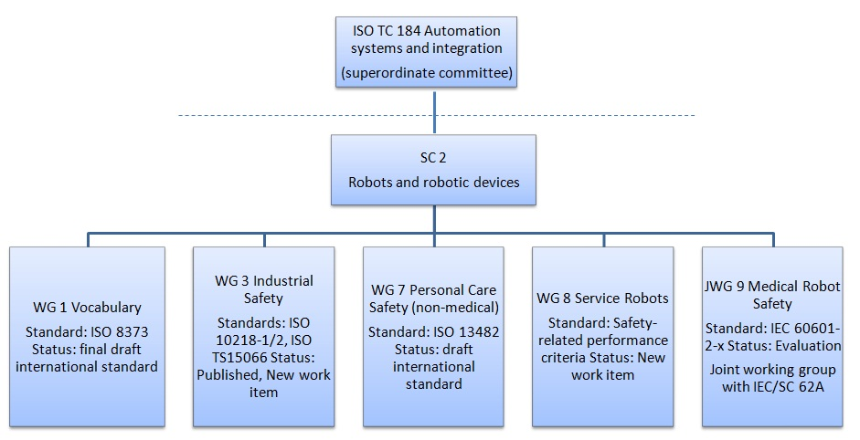

Figure 5. ISO TC184/SC2 committee

## 8.2 JRA

In Japan, Japan Robot Association (JRA) was formed with the aim to advance the growth of the robot manufacturing industry by encouraging research and development on robots and related system products, and promoting the use of robot technology in industry and society. JRA also released specification for ORiN (Open Robot/Resource interface for the Network) which is a standard network interface for factory automation (FA) systems. ORiN provides following features, (i) Unified accessing model and data representation, (ii) Variable and file based access to the resources in the device, (iii) Applicable to various devices in the factory, (iv) No device modification is required for ORiN connection, (v) XML data representation to cooperate with other systems (vi) Easy device access over Internet with simple parameter setup and vii. Configurable application interface. ORiN application was proposed as an annex of ISO20242-Part4 and approved in July 2010.

# 9 Proposal

This report identifies the need to standardize wireless communication technologies that address the specific needs of robotic systems. Robots require high degree of accuracy and reliability to ensure desirable outcome through complex sensor-actuator interaction systems. Due to unique deterministic and reliable communication requirements of the robotic systems, requirement of separate wireless spectrum for robotic applications is identified. Standards developed for wireless robotics may find applications in other related areas of cyber physical systems. We propose GISFI to initiate work on standardisation aspects of three categories of wireless communication for robotics described in detail in Section 7.

Further, the following specific requirements for standardisation in wireless robotics are proposed:

* Vocabulary of wireless robotics needs standardization. Currently, there is only one initiative from ISO to define vocabulary for mobile robotics.
* Current wireless communication standards do not meet the requirements of the high QoS and zero-failure performance. Hence, new wireless communication standards addressing these requirements must be developed.
* Wireless robotic applications require dedicated spectrum that can provide adequate bandwidth and free from external interference.
* Wireless robotic applications require spectrum which has low atmospheric attenuation
* Thin wireless robots require infrastructure support for network based control, computation, storage and navigation. Cloud computing architecture to provide Robotics as a Service (RaaS) needs standardisation.

Annexes are only to be used where appropriate:

# Annex <A>: <Annex title>

# Change history

It is usual to include an annex (usually the final annex of the document) for reports under TSG change control which details the change history of the report using a table as follows:

|  |  |  |  |  |  |  |  |
| --- | --- | --- | --- | --- | --- | --- | --- |
| **Change history** | | | | | | | |
| **Date** | **TSG #** | **TSG Doc.** | **CR** | **Rev** | **Subject/Comment** | **Old** | **New** |
|  |  |  |  |  |  |  | 0.0.0 |
|  |  |  |  |  |  |  |  |
|  |  |  |  |  |  |  |  |
|  |  |  |  |  |  |  |  |
|  |  |  |  |  |  |  |  |
|  |  |  |  |  |  |  |  |
|  |  |  |  |  |  |  |  |
|  |  |  |  |  |  |  |  |
|  |  |  |  |  |  |  |  |
|  |  |  |  |  |  |  |  |
|  |  |  |  |  |  |  |  |
|  |  |  |  |  |  |  |  |