Title: Cloud & SeON Framework, Gap Analysis and Architecture
Company: NIKSUN, Huawei
Author(s): Parag Pruthi, Ashutosh Dutta, Niranth Amogh
Contact information: adutta@niksun.com
Purpose: Discussion and approval
Doc number: GISFI_CSeON_201209310
Meeting: GISFI#10, Delhi, India, 10-12 Sep, 2012

Purpose and Scope
Service oriented network principles provide the necessary foundation for delivering the vision of convergence of service delivery for multiple market segments. This document elicits these principles in the form of requirements, gap analysis, business models, QoS considerations and architectural options. It also covers the efforts made world-wide in this area and describes the objectives and missions of Indian government in the area of convergence and cloud services documented in the NTP (National Telecom Policy) 2012 and the Draft National Policy on Information Technology 2011.

[One of the significant challenges for making service-oriented architectures (SOA) effective for enterprise systems is quality of service (QoS) management because of the dynamic, flexible, and compositional nature of SOA. QoS management must be integrated into service-oriented enterprise architectures. It must support a set of common QoS characteristics and provide comprehensive QoS services end to end, from application, to middleware, and to network and from source hosts to destination hosts across a network. QoE (Quality of Experience) for an end-user in a service oriented network can be attributed to QoS at various layers, such as at the radio layer, network layer and application layer. Having a correlation among the data at various layers helps to determine the bottleneck in the network. Thus, there is a need to have sensors at different layers that can report the quality of service based on various required network parameters. The Service Oriented Network (SeON) requires a set of mechanisms that can report QoS parameters of the network components at various layers. This document discusses a measurement-based QoS framework that analyzes performance parameters based on granularity of time. This document enumerates the set of assumptions that make up the foundation for QoS framework.]

Table of Contents
Purpose and Scope 1
EXECUTIVE SUMMARY 3
1 GISFI CSeON OVERVIEW 3
1.1 Scope of CSeON Working Group 4
1.2 Inputs to CSeON Working Group 4
1.2.1 ITU-T 4
1.2.2 ETSI TISPAN 4
1.2.3 IEEE P1903 (NGSON) 5
1.2.4 3GPP 5
1.2.5 Ministry of Communication and Information Technology (MIT) 5
1.2.5.1 Telecommunication Engineering Center (TEC) 6
1.2.6 Cellular Operators Association of India (COAI) 6
1.2.7 GISFI Technical Committees 6
1.3 Expected Results of Cloud & SeON Working Group 6
2 HIGH-LEVEL REQUIREMENTS/GUIDING PRINCIPALS 6
2.1 General 7
2.2 India Government Regulatory Requirements 13
2.3 Special Requirements for Rural India 15
2.4 End-User Services and Applications 16
2.5 Content and Transport related requirements 18
2.6 Service related requirements 20
2.7 Underlying Network/Support Capabilities 21
2.8 Business Model driven Requirements 24
2.9 Requirements for Mobility Management 27
2.10 QoS KPI: 32
2.11 Cloud Requirements 34
3. Gap Analysis 35
4. CSeON Framework 36
5. Architectural Options 38
6. CONCLUSIONS 38
7. ACRONYMS & ABBREVIATIONS 38

EXECUTIVE SUMMARY
The GISFI Cloud & Service Oriented Network (CSeON) Standardization Working Group is driven by the business needs of the Indian market. The goal is to produce CSeON standards, consistent with the unique Indian regularity, business and infrastructure (urban as well as rural India) requirements.
The GISFI CSeON requirements and framework document contains a snapshot of CSeON target objectives and features, for which phased implementation requirements will be developed.
GISFI will work with groups (e.g. ETSI TISPAN, ATIS, IETF, 3GPP, ITU-T, IEEE) to develop a consistent set of CSeON specifications that meet the needs of GISFI members. To comply with unique Indian requirements/standards, GISFI plans to share this document with all of its internal technical committees and other external groups where and when appropriate.

1 GISFI CSeON OVERVIEW
This document defines the current view of the requirements for Cloud & Service Oriented Network architecture with interfaces to existing networks. Whereas traditional networks have been focused on “unimodal” services (such as voice services), Cloud & Service Oriented Networks are intended to support multimodal communication environments where information can be communicated through a variety of terminal devices, network access technologies, and underlying infrastructures. The information may be presented in real-time (e.g., interactive voice) or time-shifted (e.g., voice mail), in its original format (e.g., analog speech) or transformed (e.g., file attachment). The information can be delivered by the network to a location, a device, or a person, reflecting personal preferences and mobility options.
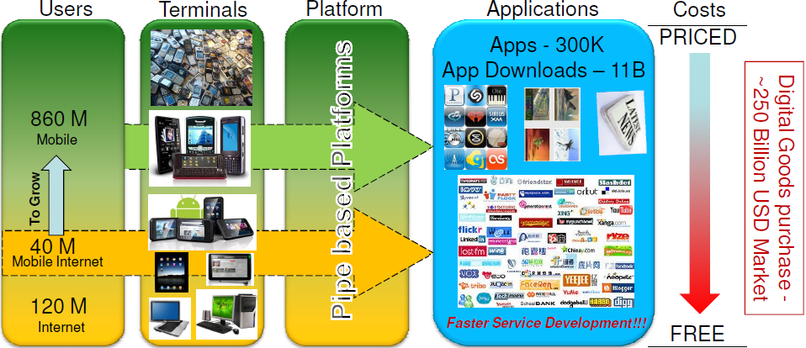
Figure 1: Indian Market Scenario
The number of mobile subscribers is increasing at a high rate and is only next to China. Even the mobile internet growth is increasing steadily owing to the proliferation of end user devices which deliver various levels of user experience. The application space has been struck by various innovations quite rapidly and has now being delivered by Over The Top (OTT) providers using the telecom network. A study from TellLabs suggest that operators or telecom service providers worldwide especially in developing countries need to transform their networks and business models to be aligned to Cloud and Service Oriented Networks in the next 3 to 5 years.

1.1 Scope of CSeON Working Group
The GISFI Cloud & Service Oriented Network (CSeON) Standardization Working Group is driven by the business needs of the Indian market. The goal is to produce CSeON Standards, consistent with the unique Indian regularity, business and infrastructure (urban as well as rural India) requirements. The GISFI CSeON Working Group will focus on providing a phased business-driven action plan for achieving implementable and interoperable CSeON standards.
The CSeON will review the existing Cloud & Service Oriented-related industry material to identify potential overlaps and gaps.

1.2 Inputs to CSeON Working Group
Following is the list of other standards forums that could collaborate closely with the GISFI CSeON WG or provide ongoing liaisons. These include:
♦ ITU-T: SG13, including the Focus Group on Next Generation Networks (FGNGN)
♦ 3rd Generation Partnership Project (3GPP)
♦ European Telecommunications Standards Institute (ETSI) TISPAN
♦ IEEE P1903 (NGSON) project
♦ 3rd Generation Partnership Project #2 (3GPP2)
♦ Ministry of Communication and Information Technology (MIT)

♦ Cellular Operators Association of India (COAI)
♦ GISFI Technical Committees

1.2.1 ITU-T
The appropriate ITU-T Study Groups, including SG13 and its Focus Group on Next Generation Networks (FGNGN), are responsible for the global standards surrounding CSeON related telecommunications. The ITU-T work can be expedited by having individual organizations or regional Standards Development Organizations (SDOs) submit contributions to the ITU-T that have a regional consensus. While this approach may not eliminate the need for collaboration between GISFI and other standards bodies, it should reduce the amount of such collaboration required, while resulting in more harmonized global standards. Such a workflow recognizes the global scope of the ITU-T, while expediting a path for regional input from GISFI into the global standards. Further more, this flow does not exclude the ability for GISFI to develop regional extensions for the ITU-T standards, although such extensions should be minimized and created only when truly needed. The goal is a universal global standard without the need for regional extensions.

1.2.2 ETSI TISPAN
TISPAN is the ETSI core competence center for fixed networks and for migration from switched-circuit networks to packet-based networks with an architecture that can serve in both. TISPAN is the result of the merging of Telecommunications and Internet Protocol Harmonization Over Networks (TIPHON) and Service and Protocol for Advance Networks (SPAN) groups in ETSI. TISPAN is the ETSI group responsible for all aspects of standardization for present and future converged networks, including the CSeON and including service aspects, architectural aspects, protocol aspects, QoS studies, security related studies, and mobility aspects within fixed networks, using existing and emerging technologies. TISPAN is developing a architecture for CSeON based on the 3GPP IMS subsystem.

1.2.3 IEEE P1903 (NGSON)
IEEE approved the project on NGSON (Next Generation Service Overlay Network) jointly sponsored by ComSoc (Communications Society) and CAG (Corporate Advisory Group) on March 2008. The group has produced an architecture specification - IEEE Standard for the Functional Architecture of Next Generation Service Overlay Networks which potentially caters to the CSeON service layer requirements for service delivery. 10 companies, which involves leading telecom operators, research institutes and vendors voted successfully for the standard. Currently the group is pursuing development of technical specifications in the areas of service composition, content delivery and self organization.

1.2.4 3GPP
The 3rd Generation Partnership Project (3GPP) is a collaboration agreement that was established in December 1998. The collaboration agreement brings together a number of telecommunications standards bodies known as Organizational Partners (see < http://www.3gpp.org/Management/OP.htm >). The current Organizational Partners are GISFI, ARIB, CCSA, ETSI, ATIS, TTA, and TTC.
The establishment of 3GPP was formalized in December 1998 by the signing of the 3rd Generation Partnership Project Agreement (see < http://www.3gpp.org/About/3gppagre.pdf >).
The original scope of 3GPP was to produce globally-applicable Technical Specifications and Technical Reports for a 3rd Generation Mobile System based on evolved Global System for Mobile communication (GSM) core networks and the radio access technologies that they use. The scope was subsequently amended to include the maintenance and development of the GSM Technical Specifications and Technical Reports including evolved network and radio access technologies – e.g., General Packet Radio Service (GPRS), Enhanced Data rates for GSM Evolution (EDGE), Universal Mobile Telephone System (UMTS) and IP Multimedia Subsystem (IMS).
3GPP2 is a parallel partnership covering specifications for CDMA-2000. Both 3GPP and 3GPP2 are closely aligned with ITU-T 3G standards.

1.2.5 Ministry of Communication and Information Technology (MIT)
The Department of Telecommunication (DoT) unde the Ministry of Communication and Information Technology drafted the National Telecom Policy 2012 and was approved by government on 31st May 2012. The MIT has also released a draft of the National Policy on Information Technology in October 2011. Both of these policies highlight the pressing need to employ principles of convergence of services, networks and devices as well as enhancing the service delivery capabilities based on Cloud computing.

1.2.5.1 Telecommunication Engineering Center (TEC)
Telecommunication Engineering Centre (TEC) is a core technical wing of the Department of Telecommunications (DoT), Ministry of Communications and Information Technology, Government of India.

1.2.6 Cellular Operators Association of India (COAI)
COAI is non-profit, non-governmental society dedicated to the advancement of communication, particularly modern communication through Cellular Mobile Telephone Services in India. Its vision is to establish and sustain a world-class cellular infrastructure and facilitate affordable mobile communication services in India.

1.2.7 GISFI Technical Committees
GISFI Network Security and Quality of Service (QoS) Groups will contribute about Network Security and Quality of Service (QoS) related matters.

1.3 Expected Results of Cloud & SeON Working Group
The GISFI CSeON will provide a phased business-driven action plan for achieving implementable and interoperable standards. The CSeON WG will work with GISFI Technical Committees to ensure this work plan leads to implementable protocol standards for the Indian market, within the context of a common international set of CSeON standards. Contributions and liaisons will also be provided to other organizations working on CSeON standards, in particular ETSI TISPAN, 3GPP, IEEE P1903 and ITU-T FGNGN (and any follow-on and related Study Groups or Questions in the next ITU-T study period).

2 HIGH-LEVEL REQUIREMENTS/GUIDING PRINCIPALS
Service providers are highly interested in leveraging existing networks and infrastructure to increase the value of those networks by enhancing their ability to offer customers “seamless” delivery of applications independent of any access or transport technology. This framework provides a common architecture and set of service interfaces to address this basic goal. Adhering to this architecture and to the services and service models set forth provides a common framework for delivering services, irrespective of the network context. Regulatory requirements may affect any telecommunications services provided. These requirements can be classified broadly in a framework as shown in the below figure:
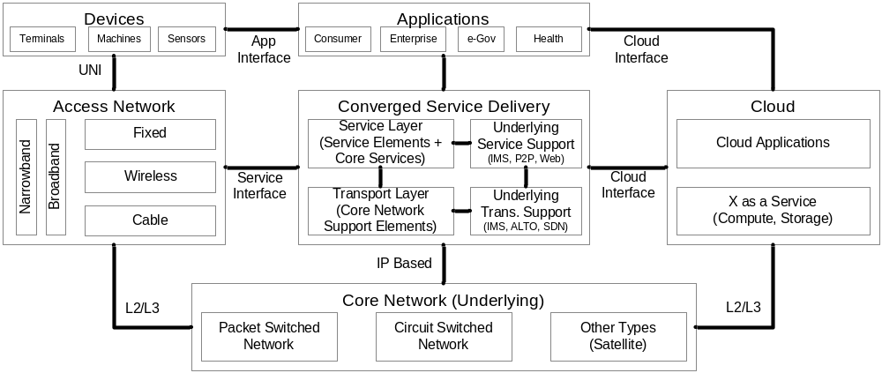Figure 2: Cloud & SeON Framework

2.1 General
The new CSeON target architecture must not only separate services from transport, but must enable efficient interworking between applications to support innovative converged services. Many of today's services are vertically-integrated which inhibits integration with other applications. This interworking can add value to existing as well as new services by integrating them into the larger convergence of media and access modes, allowing service providers to roll out the kind of customized and convenient advanced services that segments of their markets are already asking for today. By putting the disparate parts of the communications puzzle together (such as wireline and wireless services, switched and IP networks, voice and other media, and access modes of all types), service providers have the flexibility to create the right combinations of services for their markets and deploy them to the benefit of end customers.
To make the transition to a fully converged CSeON network, service providers need a standards-based, converged service-enabled network architecture that is ready and able to deliver value-added services. To fulfill these needs, the resulting architecture should support:
♦ Open, standards-based interfaces allowing “plug-and-play” integration of any number of applications.
♦ Full convergence of services over a number of access modes –- blending instant messaging with unified communications and VoIP, for example.
♦

2.1.1 CSeON Network Interconnection
Services must operate seamlessly across CSeON infrastructures provided by multiple network providers. Interconnection should extend to security, OAM, and restoration and repair with the goal of providing consistent service quality end-to-end, improving security and billing/accounting, and reducing operating costs. Providing robust, scaleable, billable, QoS-enabled, and service transparent interconnection arrangements between network providers will require significant enhancements to the definition, specification, and operation of trust-based networks.
Packet-based networks provide opportunities for enhanced services and reduced costs. The method for interconnecting packet-based networks in the CSeON should be through the use of packet-based interfaces. If these packet networks must be interconnected in the interim using TDM and ISUP, then the value of these networks is – at best – limited. Network interconnection using packet-based interfaces can address this issue and dramatically increase the value of the CSeON. Packet-based interconnection scenarios will increase the importance of an effective and secure mechanism for seamless control and management of network services.

Other inter-connection areas for consideration are:
♦ QoS measurements;
♦ Lawful Intercept;
♦ Performance measurements and agreements;
♦ Robustness, reliability, redundant interfaces, and failover;
♦ Voice services, but many of the concepts therein can be applied to other services, including VPN, multimedia, and video.
♦ Monitoring;
♦ Security and trust management;
♦ Inter-provider Security incident resolution;
♦ Inter-provider accounting support;
♦ Default codecs and trans-coding for end-to-end voice and video services;
♦ IPv4 to IPv6 migration and interconnect;
♦ Telephone number to IP address mapping;
♦ Access to shared directory information; and
♦ Interconnection of services for people with disabilities.

In addition, there might be different interconnection and interworking requirements for different service providers. For example, interconnect between two network service providers will require different interfaces and agreements than an interconnection between a network service provider (e.g., ISP) and an application service provider (e.g., email or content provider).

2.1.2 Interface between Application Service Providers (ASP) and Next Generation Service Providers (NGSP)
For the purposes of this section, an ASP is a business entity that offers application services to its customers via the NGSP and uses communications services offered by the NGSP. Thus the ASP depends on the NGSP for offering services to its customers.
The ASP does not necessarily provide packet transport for customers although it might relay information between customers of the application service.
CSeON architecture shall provide provision to the operating NGSP to expose service interfaces which can be accessed securely and accountably by the ASP
For example, in the current Internet model, an ASP providing email services to customers (both send & receive) might relay email between customers; i.e. the ASP would work at the application level to route messages and would leverage the NGSP to route datagrams or blend the email with other services offered by NGSP.
In addition, an ASP typically would provide a value added service to users of an application that requires manipulating the information; for example, the email provider might provide an anti-spam service that filters email based on user-provided criteria.
A different example would be an ASP providing conferencing services. In this case the ASP would terminate the media streams (i.e., IP packet flows), mix them and send them back out to the participants. In this case, the application information is the media stream and its control protocols.
A complete list of applications provided by an ASP in the CSeON model is not attempted here. New applications can be invented and provided over the CSeON via software installed at each endpoint without requiring modifications to the NGSP’s network or services. Examples of applications currently offered by ASPs over the Internet include email, gaming, e-commerce, web hosting, content caching, etc. Examples of application services that ASPs could provide over the CSeON in the future include cooperative computing (e.g. becoming a central coordinator itself for multiple disparate services on the CSeON), grid/cloud computing, environmental sensing, etc
In the Internet, new services, applications and markets have been originated by customers of Internet Service Providers (e.g., WWW, Peer-to-Peer networks, e-commerce) that have created new business for ISPs and added value to the Internet. Similarly, given a fertile ground to grow, new services will originate from customers of the NGSP. The ASPs offering these new services could begin by using Transport Services from the NGSP to connect to their customers and then migrate to Application Services as the services and markets mature. Alternatively, the NGSP can introduce new services to its customers that will generate new markets and ASPs (who will then purchase services from the NGSP) as the markets mature.

2.1.3 Mechanism to Measure and to Predict Service Quality
The CSeON should include mechanisms to measure and to predict service quality. Measurements can be made by intrusive or non-intrusive mechanisms. The use of non-intrusive measurements and define appropriate standards to correlate layer 2 measurements with upper layers should be investigated. The use of intrusive measurements is not recommended because the statistical samples do not have tight confidence intervals with bursty network traffic. Often, measurements occur independent of one another and therefore correlation becomes a major obstacle in obtaining meaningful results from these measurements. A synchronized mechanism for non-intrusive measurements is desirable.
These highly correlated measurements can then be used to drive real-time decisions that can provide tighter bounds on end-to-end service quality metrics.

2.1.4 Public Service Provider (Fixed & Mobile) Convergence
The CSeON must support effective wireless/broadband integration. Specifically, services should be enabled to be accessed from all types of access networks, including copper DSL, broadband fiber, wireless LAN, cellular wireless, etc.
It will be a requirement that users have the ability to access and use their communications services and network-stored information (service settings, personal data, archives, etc.) from anywhere, any technology, any network, and any device (subject to the inherent service limitations of the access and device) especially the mobile phone (Clause 3.14 NTP 2012). Services (e.g., social networking or video distribution) should operate seamlessly across wireless and wireline networks in a CSeON infrastructure.
CSeON convergence can be defined from the user’s perspective as the ability to access and use communication services regardless of location, across multiple access technologies, using any of a variety of terminal devices. This definition represents the ideal. The reality will be gradual evolution towards that ideal.
CSeON convergence – in the broadest context of mobile, broadband integration – supports a fundamental shift towards an end-user-centric world allowing end-users access to their services from any combination of device and access medium while maintaining a consistent personal profile (e.g., service subscription, personal preferences, single billing, etc.). This transition enables a wide list of new service opportunities, but identifying the most-likely successful services among such a list requires a new way of segmenting the market to better understand end-user needs.
Today, end-users are approached by the telecom industry in a very fragmented way:
♦ Separate identities for fixed, mobile, broadband, and Internet services (e.g., fixed phone number, mobile phone number, multiple IM-IDs, multiple email addresses, etc.).
♦ Separate interactions with the service providers (e.g., subscriptions, billing, customer care, etc.).
♦ Separate service capabilities depending on device used or means of access (e.g., in terms of messaging – SMS, MMS, IM, email, voice mail, etc.).

Such a fragmented approach may be attributed to external forces shaping the telecom industry, including rapid technology evolution and regulatory changes. However, a result of this fragmented approach is unnecessary complexity, frustration, and cost for the end-user. Given ongoing technological evolution associated with fixed and mobile broadband, VoIP, and the like and the corresponding market dynamics associated with threats of substitution or competition, it is expected that successful service providers will shift from the network-centric to an end-user-centric model.
An end-user-centric market means:
♦ The emergence of a new generation of end-user services (communication, content, and application) enabled by broadband, without the traditional restrictions of separate networks.
♦ The capability for end-users to have access to any service over any appropriate access means/device.
♦ A shift towards service delivery in an end-user-centric way, with a single personal profile (single subscription, single preferences, settings, single bill, etc.) being a key service component.
The new generation of end-user services will consist of innovative combinations of:
♦ Communication services:
- Voice, text and video conferencing with IM.
- Messaging interoperability via any device (SMS, MMS, IM, email).
- Video, text and voice communication, conferencing and online multimedia collaboration.
- Content conversion: (e.g. relay services for translating between languages and different media (sign language, text, voice).
♦ Content and applications:
- Entertainment: Gaming, music, broadcast television, on-demand video and interactive services.
- Commerce: Shopping.
- Information: News, traffic.
- Productivity: Intranet Access, VPNs.
- Automation: Home/car/pet security, surveillance, child monitoring, managed homes for elderly care.
♦ A personal profile across different access media and end-user devices.
The NTP 2012 provides the objectives of repositioning the mobile phone as a principal element for all kinds of service delivery, converged networks for enhanced service delivery and Fixed-Mobile convergence under the clauses 3.14, 3.16, 3.18 and 3.25.
Ex. The convergence of fixed and mobile infrastructure may require additional media resource functions such as the need for transcoding between different speech codecs (such as EVRC in a 3G handset ↔ G.711 in an IP landline phone).

2.1.5 Public Service Provider (Fixed & Mobile) and Customer Premises Network Convergence
The services offered through CSeON should operate seamlessly and transparently across public mobile/fixed and customer premises networks. For instance:
♦ A member of an enterprise can easily, efficiently, and securely access critical enterprise data from a visited location (another person’s premises network) using a mobile phone.
♦ A user with a dual-mode handset that operates as a WiFi cordless phone in the building and a 3G handset outside the building can maintain a telephone conversation continuously while moving in and out of the building.
♦ A wireless mailbox is accessible from a customer premises network such that a user has the flexibility in selecting the way to retrieve mail based on the networks available.

2.1.6 Access Criteria for CSeON Conformance
One of the key objectives of the CSeON is having services independent of access – e.g., the ability to use a range of technologies for the IP Connectivity Access Networks (IP-CAN). The CSeON will place interface requirements on the IP-CAN for any access technology to be included as part of the CSeON. An IP-CAN deployment that does not support these requirements may not realize the full set of CSeON capabilities. Any IP-CAN that meets these requirements shall be supported by the core IMS network, although it may not support all CSeON services. For example, a low bandwidth IP-CAN might support voice services but not video. Similarly, a high latency IP-CAN might support non real-time services, but not interactive voice and video.

2.1.7 Infrastructure Evolution for Incremental Replacement of Legacy Services
The CSeON will replace today’s telecommunication services (i.e., “legacy services”) over time, although this is not the primary objective. The primary service objective of the CSeON is to create an open service environment that will support the efficient introduction of new, revenue-generating multimedia services. In this sense, the CSeON has three service goals:
- Support for converged multimedia services, based on the 3GPP IMS (SIP based) architecture.
- Support for Interconnection and interoperation with the existing PSTN. This requirement is likely to be an important capability of the CSeON for some time. The PSTN requires certain capabilities and functions in connected networks for such areas as security, accounting, etc. To the extent a CSeON expects to interwork with the legacy PSTN, including sending or receiving calls to PSTN users or accessing resources in the legacy PSTN, the CSeON will need to support appropriate functionality. The necessary capabilities for the CSeON to interwork with the PSTN can have implications in the CSeON beyond the edge device that provides connectivity to the PSTN.
- Support for legacy services and terminals. This requirement is not simply based on the need for the CSeON to eventually replace the legacy PSTN. There is also a requirement to decouple the replacement of the PSTN network infrastructure from the replacement of PSTN services and terminals. There may be a need for some existing PSTN services to continue to be supported indefinitely, with exactly their current functionality. If the IMS based CSeON does not transparently support these services, this could either delay the replacement of the PSTN infrastructure, or force long-term costs into the target network simply to support transient (legacy) service requirements.
It is important that these two goals be kept distinct. If they were to be merged, it is likely that the resulting solution would not be optimal for either goal. It could lead to gaps in the legacy service coverage, and to unnecessary complexity in the target CSeON. The CSeON will contain distinct subsystems to support:
- SIP-based multimedia services; and
- Legacy PSTN services.

These subsystems should share common standards and infrastructure to the extent that this does not compromise the primary objective of optimizing each subsystem for its primary role.

2.1.8 Technology for Services in a Converged Network
The technology for developing services should be network and application protocol independent. There are several reasons for this:
♦ It is not economical to deploy a multiplicity of development and delivery environments.
♦ It is not economical to deploy separate physical networks for each service as they are rolled out.
♦ Service development and delivery technologies that are tightly coupled to specific networks and protocols violate the software engineering practice of “separation of concerns.” The service developer should concentrate on what’s delivered to the user, not how that service is implemented in a particular network.
♦ The infrastructure that gives users a converged experience can be expected to be a mix of both IP and non-IP technologies for the foreseeable future.
♦ Service creation could be done by any third party developers (e.g., from the IT environment), and not just by trusted developers working directly within the telecom environment.

2.1.9 Synchronization and Timing Issues
Historically, synchronization and timing has often been an afterthought, investigated when the Quality of Experience (QoE) of the end-user dropped below an acceptable level. The modern PSTN is well synchronized; with the majority of digital network elements provided a timing reference traceable to a Primary Reference Clock – mainly because without a “common clock” there were significant problems with voice-band modem performance. The advent of ISDN reinforced the need for good network synchronization. The preponderance of customer premise equipment connected to the network over digital facilities (especially E1 and T1) utilizes the network feed as a timing reference source. Good synchronization is an enabler to elevate performance from mediocre (at best) to carrier-class. Wireless operators have found that attention to good synchronization resulted in fewer dropped calls and customer complaints. It is unlikely that the need for good synchronization will become moot with the advent of CSeONs.

2.2 India Government Regulatory Requirements
The regulatory requirements are, to a certain extent, a moving target with evolving legislative and regulatory actions by the governmental bodies of various jurisdictions. In many cases, regulations are service specific, with traditional telecommunications services having a larger regulatory footprint than newer services; for example, voice (telephony) services have a larger footprint of regulatory action and case law than newer services such as instant messaging. The regulatory classification of specific services (e.g., basic telecommunications services vs. information services) significantly impacts the requirements for those services. A number of regulatory requirements have developed from this legacy of voice services, and these regulatory requirements may expand to affect CSeON services.

2.2.1 Lawfully Authorized Electronic Surveillance (LAES)
Indian Government Information Technology Act, 2008 requires carriers to provide certain electronic surveillance capabilities to law enforcement agencies.
The Telecom Regulatory Authority of India (TRAI) has lifted the restrictions on Internet telephony in India. The recommendations under “Issues Related to Internet Telephony” permit ISPs to provide unrestricted Internet telephony (termination of Internet telephony calls on PSTN/PLMN and vice-versa) within the existing IUC regime. All ISPs interested to provide unrestricted Internet telephony needs to install lawful interception equipments. CSeON should satisfy LAES requirements.
The details of this topic, will be covered by GISFI Security & Privacy Working Group.

2.2.2 Number Pooling
The Telecom Regulatory Authority of India (TRAI) has suggested that TEC should identify distinct number resources for Internet Telephony subscribers and Telephone numbers from identified blocks should be allocated to ISPs, UASPs, BSOs and CMSPs for Internet telephony. CSeON should be able to integrate provide services to Internet Telephony subscribers.

2.2.3 Number Portability
The Telecom Regulatory Authority of India (TRAI) has issued a draft of regulations for introduction of mobile number portability (MNP) in the country. Mobile Number Portability will allow subscribers to retain their existing telephone number when they switch from one access service provider to another access service provider irrespective of mobile technology or from one technology to another technology on the same or any other access service provider.
Mobile number portability would also work for Indian pre-paid mobile phone connections. In this case, the balance in the existing pre-paid card would be exhausted, or would be lost.
Donor operator will not be able to use the ported out number till it is in use by the ported subscriber. After the surrendering of number by ported subscriber, the number will revert back to the original donor operator. Mobile subscriber shall be eligible to make a request for "porting" (changing) his mobile number upon expiry of a period of ninety days from the date of activation of his present mobile connection.
The process of transferring a mobile number from one provider to another would involve a break in service when a number is detached from one provider and added to another. TRAI has said that this period should not be more than two hours.
The recipient operator, within five days of receiving a written request, has to carry out subscriber verification according to the guidelines for acquiring a new user. Upon verification, the request is to be forwarded to the donor operator (to whose network such mobile subscriber number currently belongs) for seeking its clearance.
Upon receipt of the porting request, the donor operator shall verify and communicate the details to the MNP service provider within two working days. The MNP impact on service continuity should extend to CSeON services.

2.2.4 Emergency Telecoms Service (ETS)
The Telecom Regulatory Authority of India (TRAI) has not mandated emergency number dialling to ISPs. This should be examined further by GISFI whether emergency connections via telephony and/or IP should be mandated across the board. Response to natural or unnatural disasters can be greatly improved if the networks themselves provide for emergency connections, status updates, interconnects with disaster recovery or government agencies, etc.

2.2.5 Accounting
2.2.5.1 Indian regulations
The Telecom Regulatory Authority of India (TRAI) has regulatory requirements regarding Intra-state tariffs. TRAI Regulations would apply to inter-state tariffs. Taxes and other fees may apply to various commercial transactions with associated requirements for identification.
2.2.5.2 Industry Direction
In some cases there may be rules regarding compensation among networks and users that need to be accommodated. In other cases there may be fees or charges due to various governmental agencies, etc. These various rules can require identifying to billing entities the originating and terminating users, their locations, the networks involved, the services used, and the volume and nature of traffic.

2.2.6 Value Added Services
NTP 2012 has provided an objective under the clause 3.19 to provide a platform for innovation in Value Added Services by involving various stakeholder in the VAS value chain. CSeON should satisfy this clause.

2.3 Special Requirements for Rural India
70% of country population lives in Rural India. There are almost 600,000+ villages in the country with 1000 people per village and per capita income of Rs. 20 to 25 per day. The rural tele-density in India is 18.97% as compared to urban tele-density of 101.38%, as on 30.09.2009. The country’s tele-density is 44.87% as on 31.10.2009 compared to world’s tele-density of 78.11% as on 31.12.2008 (last available).
The people in rural India, needs connectivity in order to be fully connected to the progressing world in order to make it a truly symbiotic society. For telecom operators, it is thousands of customers subscribing every day while for equipment vendors it brings a unique challenge to develop new solutions that provide the access to these communities.
Following are the requirements specific to rural India,
- Low population density
- Low income levels
- Lower literacy levels
- Sparsely populated and geographically dispersed areas
So any business model prepared for rural area should be:
- Affordable (cheaper)
- Reliable
- Rich in Contents (like Value Added Services specific to the needs of people working in agricultural domain)
- Available in local language
- Self sustainable
- Replicable
- Scalable
- Easier and faster to deploy
- Deploy alternate source of Energy like Solar power
- Low maintenance and Support Cost
Low maintenance network equipment suitable for rural environment considering the following factors,
- Lack of continuous power supply
- Lack of high available infrastructure
- Harsh environmental conditions
- Low literacy level

Harnessing the Technology for Rural Connectivity
In the present network environment, mobile communications has proven to be one of the most effective ways to provide rural coverage. The high volumes has lowered the cost of technology down significantly and brought the technology available for an increasing number of users. Of course, the mobile business themselves also spur economic activity, with local franchisees or entrepreneurs taking the opportunity to run their own mobile access businesses. In some regions, airtime is already being traded as a new form of currency. Involvement of local entrepreneurs of rural areas can play important role. They can/may be asked to associate in initial investments in villages. A villager may not have seen a computer but he can easily communicate in his local language.
Thus companies suggesting the solution to such requirement should keep in mind that technology should be harnessed to change the face of rural community by providing urban amenities to the under-privileged, living in the rural areas and that is possible by offering them connectivity in a cost effective way. The emerging technology, tools and benefits of the knowledge economy can actually help transform the dream that we have for our villages into reality. CSeON services should be able to reach the rural mass and also modeled specifically for rural population through the adopted connectivity technology.

2.4 End-User Services and Applications
Customer services market is driven by innovation, service and quality. Myriad applications are developed to satisfy the needs and quality expectations of the end-user. All these applications have their specific network requirements resulting in grouping of applications based on these network requirements. In the current scenario a set of applications require a specific hierarchy of network infrastructure. In the CSeON all sets of applications will be supported on a common, converged network infrastructure.
This will involve developing a comprehensive grouping of applications which will serve as the basis for identification of the requirements for a converged CSeON. Some of these application sets could be grouped as following:
- Remote banking
- Remote advertising and marketing
- Interactive gaming
- Content sharing
- Voice applications

2.4.1 Remote banking
The CSeON is envisioned to support applications that provide remote banking services. Banking applications involve monetary transactions which require strict constraints in terms of network availability, reliability and security. Recently in India there has been a phenomenal growth in the use of Mobile Banking applications, with leading banks adopting Mobile Transaction Platform and the Reserve Bank of India publishing guidelines for mobile banking operations. Some of the factors that must be considered while developing network infrastructure that supports banking applications are as follows:
- Availability. With mobile banking customers are able to access a banking-application from any part of the world and at anytime. Hence, the network must be highly available, up and running in a 24X7 fashion.
- Scalability. The ease of access may result in an exponential growth in the customer base. The network infrastructure must be highly scalable to support the continuously growing customer base.
- Reliability. Banking applications involve monetary information and transactions. The network infrastructure must be highly reliable to support this kind of communication. In CSeON the network communication reliability is guaranteed.
- Security. It is vital to standardize the security features for CSeON, because of the critical nature of financial data transfer. The financial messages should have the under noted features:
- The receipt of the message at the intended destination
- The content of the message should be the same as the transmitted one
- Sender of information should be able to verify its receipt by the recipient
- Recipient of the message could verify that the sender is indeed the person
- Information in transit should not be observed, altered or extracted
- Any attempt to tamper with the data in transit will need to be revealed
- Non-repudiation

2.4.2 Remote Advertising and Marketing
In India, remote (mobile or internet) advertising and marketing is at a very early stage with mobile advertising limited mostly to bulk SMSs, but it is a fast growing market. It does not involve much of reliability and security constraints. It requires advanced multicasting based on user groups and content and safeguarding the end-users’ interest relating to location and permission based marketing.

2.4.3 Interactive gaming
Interactive gaming encompasses a broad range of virtual environments and interaction modes. Various kinds of network devices like gaming consoles, PDAs, laptops etc. can be used to interactively access the gaming content and to interact with other remote players. Different games may require different content types such as interactive or one-way voice, video, image etc. There may be access control policies restricting the access to certain games only to a set of end-users. Interactive gaming also involves advanced multicast capabilities to support sophisticated multiplayer online games. The end-users must be authenticated and access must be controlled based on the services or games paid for. The network infrastructure must have real-time capabilities to support interactive multiplayer games.

2.4.4 Content sharing
Content sharing requires users to define “closed user-groups” or “virtual peer networks” that allow content sharing among the members. Content can be audio, video, image etc. accessible to authenticated users in an on-demand basis. Security policies must be developed to ensure authenticated access, replication and modification of content. The content can either be centrally hosted or distributed across local systems. An example could be a central repository providing information on local restaurants based on geographic locations.

2.4.5 Voice applications
Although traditionally associated with PSTN telephony voice is becoming more and more common in IP-networks. IP based voice applications are an important challenge for CSeON because of the stringent quality requirements. With low bit-rate codecs the bandwidth requirement for voice applications can be very low but the stringent delay and jitter requirements are a big challenge.

2.4.6 Government e-Health and e-Governance applications
As an initial effort to connect the medical network to the end users, telemedicine should be effectively deployed by CSeON. e-Health services should improve the accessibility of medical services to rural sector in particular. Gradually the government should be able to introduce e-Health applications like electronic health records, almost real-time automated health monitoring and emergency services, diet control and health tips.
Similarly in the area of e-Governance the applications aiding communication like Government to Citizen (G2C), Government to Business (G2B), Government to Governments (G2G), Government to Employees (G2E) and Citizen to Government (C2G) should be effectively deployed by CSeON by harnessing existing citizen identity projects like Aadhar.

2.4.7 Value added Mashup services
With the proliferation of smart phones with open operating environments, there has been a huge innovation in the space of value added services delivered on service oriented non-telecom networks. These services do not combine the best of telecom capabilities to deliver the best user experience. Hence service oriented networks must deliver value added mashup services in combination with Telecom services.

2.5 Content and Transport related requirements
Many content based services need to be supported by CSeON. There is a need of common converged infrastructure for applications. New services and applications are expected to require additional functionality from CSeON. Particular attention will be given to requirements that are unique to Indian service providers. CSeON should provide backward compatibility with the network services that the application require. Some applications such as VoIP, IPTV require use of network service enablers for providing quality voice and video contents with maximum performance.

2.5.1 Differentiated Services and Software Defined Networking
Differentiated Service architecture can be used for managing network traffic and providing Quality of Service guarantees on IP network. High priority data can be sent through or around clogged nodes ahead of low priority data. This approach allows traffic with similar service characteristics to be passed with similar traffic guarantees across multiple networks, even if the multiple networks don't provide the same service the same way. In the IPv4 TOS octet or the IPv6 Traffic class octet is used to mark a packet to receive a particular forwarding treatment, or per-hop behavior, at each network node.
An emerging architecture in this space is the Software Defined Networking (SDN), which allows the specification and global control of application specific flow contexts based on source and destination identity aspects.

2.5.2 Security
CSeON should provide same level or better security as the current PSTN. Developing effective security policies is best achieved by using a comprehensive security model such as the ITU X.805 Security Architecture. The X.805 Security Architecture allows for a structured approach to developing security policies and determining what security services need to be deployed. As Service Providers’ infrastructure consists of ICT systems, the security implications are larger and a hence this aspect is to be studied further under the GISFI Security & Privacy WG.

2.5.3 Policy-based management
Policy-based networking should be used for the management of a network so that various kinds of traffic - data, voice, and video - get the priority of availability and bandwidth needed to serve the network's users effectively. Using policy statements, network administrators can specify which kinds of service to give priority at what times of day on what parts of their Internet Protocol (IP)-based network. This kind of management is often known as Quality of Service and is controlled using policy-based network software. Theoretically, a policy statement could be as natural as:
"Provide the fastest forwarding for all voice traffic to New Delhi between 9 am and 3pm."
It may be used to improve the reuse of successful (proved as correct) management decisions (embedded into policy rules). The policy management system is a collection of rules (some can be grouped into policies; simpler policies can be grouped into more complex policies), as finer pieces that can individually constrain the behaviour of an operational system. Many approaches and technologies have been proposed to build such management systems (rule-based, scripts-based, model-based, etc.). Multiple policy-based management systems may be simultaneously required. How to build such a management system, what mechanisms are required, and what challenges these systems are raising may be crucial for the CSeON.

2.5.4 QoS/QoE
To report the quality of service based on various network parameters are required. The CSeON require mechanism to report QoE(Quality of Experience) too. Assumptions may be made on the bandwidth allocation supported by a session based admission control function. It should also be capable to support dynamic requested QoS to the Application Service Provider. (Refer the QoS/QoE KPI section for detailed requirements)

2.5.5 Multicast
CSeON should provide infrastructure to support multicast traffic. Some of the contents can be multicast so the CSeON should respond appropriately based on the contents whether they are unicast or multicast. For example application like IPTV requires support for both multicast and unicast.

2.5.6 Emergency Alerting
Content overlays notifying of emergency conditions is expected to exist in this IPTV/VOD service. In addition, emergency alerting can be provided by use of SMS, MMS, IM, etc.

2.5.7 Content Rights Management
The CSeON should allow digital certification of authenticity for the source of digital contents, authentication and authorization of the user to view the content protecting the copy rights of the content.

2.5.8 Session Management
Standard session management control commands must be defined for users to initiate and control a content delivery. Initiation commands may include search, browse, and order. Control commands may include play, rewind, forward, pause, stop, fast rewind, fast forward, etc.

2.5.9 Inter Carrier CSeON Roaming
CSeON should be capable to provide inter carrier roaming. A call or data session should not be disconnected during the switching of the carrier. Specific interfaces need to be provided and implemented by all the service providers. User experience should be independent of internal and inter-carrier functions.

2.6 Service related requirements
2.6.1 Service Discovery and Interaction
CSeON should enable on-demand service discovery and enable interaction among disparate services and among different service providers.

2.6.2 Context Aware Service Adaptation
CSeON should be able to adapt services during the service delivery to the end user based on contexts of the User, Network, Service, and Terminal. Thus, providing a superior experience of service delivery to the end user.
Personalized services: CSeON should provide interface to develop personalized network services. People can be charged based on the services provided to them like high bandwidth.

2.6.3 Mashups and Service Composition
CSeON should be able to support efficient service composition and provide mashup applications by combining disparate services and content from any kind of underlying service networks like IMS, P2P, Web or Cloud.

2.6.4 Service Virtualization
CSeON should be able to provide virtualized service interfaces, which allow developers to use single service interfaces irrespective of the different flavors offered by service providers.
Ex: An operator operating a multi-national service platform will have deployed multi-vendor services. Like SMS service interface may be different in different regions. If an application has to be introduced commonly across this deployment, the operator faces the challenge of creating regional flavors of the application. This increases the cost for the operator. Hence CSeON should be able to offer a single SMS interface for the developer to develop the application on a global scale.

2.7 Underlying Network/Support Capabilities
The CSeON requires mechanisms to support service delivery where the infrastructure is not closely integrated; specifically, multiple operators may own and operate independent parts. Management of telecommunications networks is intended to support a wide variety of management areas which cover the planning, installation, operations, administration, maintenance and provisioning of telecommunications networks and services.
CSeON management should minimize load caused by managing traffic, minimize management reaction times to network events, allow for geographic dispersion of control over aspects of the network operation, provide isolation mechanisms to minimize security risks, provide isolation mechanisms to locate and contain network faults, improve service assistance and interaction with customers and converge on a single, secure network and set of protocols for managing equipment and carrying management information.
The CSeON infrastructure should be built upon a foundation of IP-based network services; these have been developed and deployed in the context of best effort IP services. While IP protocols have been developed and deployed for many years, ongoing improvements are required to ensure the continued scalability of the IP infrastructure in the context of QoS and other network services. OAM support for validation of QoS operation may require additional support.

2.7.1 Security
Security is the most essential enablers and differentiators in CSeON. Identifying services and the users, authorizing the service to access specific content based on his access rights and authenticating the service to use appropriate resources are required.
- Access Control: Enabling access authority to control the access of the resources, protecting of copy rights. Implement the policy to describe how to secure access a data resource.
- Authentication: Confirming the identity of the person, tracing its origins and ensure that the application is the same as it intends to. This group will focus on what is needed for authentication for both device and end users and how far authentication goes:
♦ User to phone (for highly secure environments)
♦ User Agent to IMS
♦ IMS to User Agent
♦ User to IP-CAN
♦ IP-CAN to User
♦ User Agent to User Agent
♦ Cross domain authentication
♦ Authentication of Signaling messages
♦ Authentication of media packets
♦ Authentication of messages that traverse PSTN<-> Packet Networks through Signaling/Media gateways
- Non-repudiation: Techniques like Digital signature should be used not only to ensure that a message or document has been electronically signed by the person. Ensure that a person cannot later deny that they furnished the signature.
- Data confidentiality: Provide infrastructure for encryption and password authentication.
- Communication security: Platform to deny unauthorized access of data and resources. Security refers to the need to ensure that communications between endpoints cannot be unlawfully intercepted or redirected.
- Date Integrity: Assurance that data is consistent certified and can be reconciled.
- Availability: Resources and data need to be available when required.
- Privacy: CSeON can be combined with identity authentication (e.g. RFID can be used).
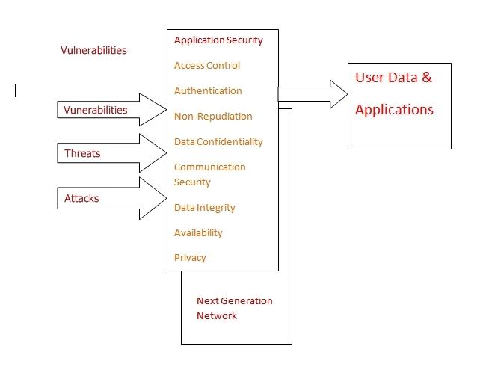
Fig: Eight Security Enablers.

2.7.2 Charging and Billing
CSeON should be capable of maintaining accounting information, like use usage summary. Billing has also been used to support other billing arrangements; perhaps the stereotypical example is the ability to use a mobile phone to pay an electricity bill. A further extension would be the ability to transfer money, shopping.

2.7.3 Service Quality Measurements
In the traditional voice context, QoE(Quality of Experience) for a voice service is well understood and established mechanisms (e.g., MOS) exist to quantify it. In the CSeON context, a variety of services other than voice are to be offered, and indeed those services present much of the rationale for evolution beyond the PSTN to a CSeON. Perceptual quality metrics will be required for these non-voice services also. Specific non-voice services requiring standardization efforts to include the equivalent of a MOS score for service quality include:
♦ IPTV
♦ Video on Demand
♦ Web site browsing
♦ Multimedia conferencing
♦ Internet radio
♦ High definition audio

2.7.4 Mechanisms to Predict Service Quality
In the existing network and given a combination of network equipment and defects, mechanisms exist to predict the expected QoE (e.g., E-model for voice). Similar mechanisms will be required to predict the QoE for future services.
In the context of voice telephony, a MOS score can be predicted given certain information regarding the choice of codec and various network transmission performance metrics (e.g., loss, delay). The E-model is a formalization of this algorithm. Similar mechanisms are required to predict service quality metrics for other services, again largely based on network performance metrics and codec options. While (hopefully) standard IP network performance metrics can be used, the codec information may be more complex in some cases. If we consider a video codec such as MPEG4, there are a variety of implementation options for decoding and error concealment techniques that can impact perceived quality in the presence of errors and loss.

2.7.5 Network and Service Disaster Recovery
The goal is to provide cost-effective survivable network. This may be limited to the power failure and terrorist attacks. Survivability should be built into the design and operation of the CSeON, and should be based on open and interoperable standards rather than proprietary technologies.
For example, in VoIP, the call server can be deployed in split or load-shared mode so that when disasters happen in one geographical location, customers can still obtain service from the call server in another location. Similar mechanism can be utilized for intra-and inter-domain transmission devices and gateways in both wire line and wireless networks.

2.8 Business Model driven Requirements
Developing CSeON takes significant effort and contribution from its participants in terms of time, manpower and money. This leaves a heavy toll on the participants which must be balanced with the expected deliverables. The expected deliverables of the effort and contribution should promise reasonable potential profits to the market participants. Incorporating business model requirements in the CSeON architecture will provide the necessary leverage from the market participants and will also help in the convergence of newer technologies and applications. The market and industry drive the direction of communications technology which in turn drives the architecture of CSeONs.
One of the most important objectives of developing CSeON is to develop a system that enables easy integration of services and operations across business units, insulating services from the underlying transport technology. This will result in the separation of products from the underlying network transport technology. A common converged network infrastructure will enable service providers to provide a wide range of services on the same network transport infrastructure.
Another important business aspect is the accommodation and interoperability of the existing infrastructure and services along with supporting new services and technologies efficiently.

2.8.1 Operational and Capital Expenses (OPEX/CAPEX)
CSeON will provide significant operational and capital efficiency over the existing vertically integrated networks through the use of a converged network infrastructure. In CSeON the applications and services are independent of the network transport infrastructure. The capability of offering a wide range of services on the same infrastructure will reduce the operational costs and increase the return on the capital expenses. CSeON will be able to handle specific application needs and hence will also reduce the effort and investment in developing support for newer and more sophisticated applications.

2.8.2 Implications for Service Providers
The end-user profile (subscriptions, billing, preferences, etc.) has key implications for service providers when moving towards an end-user-centric world with an economically-viable model. From a service development and delivery point of view, a capability needs to be developed to flexibly define, prototype, launch, and modify new services leveraging the user profile. This capability must also orchestrate a complex end-to-end service delivery chain, including third parties. Service providers may also need to complement their own access portfolio through partnerships or wholesale agreements. They may need to adjust their marketing strategy in terms of branding, pricing, etc. Finally, service providers could integrate operational activities across fixed, mobile, broadband, and Internet divisions to benefit from synergy and scale effects.

2.8.2.1 Third party access
A list of business requirements for third-party access relates to the need to benefit from a single user profile, even when this user is not on the home network of the service provider:
♦ End-users should be able to access their services through a simple access and service authentication process.
♦ Service providers must be capable of securely accessing specific user profile information (e.g., preference settings) from different networks.
♦ The CSeON should support flexible consolidated collection of settlement information such as usage. For example, all services for an end-user may be charged through a single bill for postpaid, or a single account for prepaid, for seamless roaming services between access types such as mobile access and wireless broadband access.
♦ Service providers must also be capable of collecting user information from different access networks to the service providers’ home network (e.g., location information).
Another set of business requirements relate to the challenge of delivering the same service from the service provider who owns the end-user profile (including the service subscriptions) over a third party access network:
♦ Communication services must be delivered from any access network or technology to any other access network or technology.
♦ Application and content services must be delivered from the Service Delivery Environment to any access network.
♦ The solution architecture must accommodate different types of mobility between access networks (e.g., nomadic services, roaming seamless handover, etc.), depending on the service providers’ offering and interconnection relationships.

Business requirements that relate to the handling of the different access characteristics are inherent to each access medium (e.g., DSL broadband versus wireless 3G):
♦ Services must be adjusted to fit the terminal and media characteristics of each access network (e.g., bandwidth, QoS).
♦ Where necessary, different session related control protocols in access networks must be interworked with SIP in the CSeON core.
♦ QoS and security (data integrity, data confidentiality, network security) must be maintained from a user viewpoint (or managed within the constraints of different technologies) across the access networks and the CSeON core.
♦ The end-to-end service instance may span access networks that are independently administrated by separate service providers or use different technologies.

2.8.2.2 Service Delivery Environment
Business requirements for a service delivery environment relate to the delivery of new services using service capabilities – e.g., based on the information from the end-user profile:
♦ New services should be able to make use of the service providers’ existing service capabilities (e.g., presence), both from the ‘telecom world’ (e.g., prepaid) and the ‘IT world’ (e.g., AAA) in the context of CSeON.
♦ New services should also be able to make use of third party service capabilities (e.g., location).
♦ The Service Delivery Environment (SDE) should support third party applications by sharing service capabilities in a secure way, in order to create a kind of ”eco-system.”
♦ The service creation process should be supported by a service creation environment that encompasses both ”Telecom” and ”IT” services.

Business requirements relate to the openness to the service provider environment:
♦ The SDE should also be open to the end-user for self-management purposes – e.g., through web interfaces.
♦ The SDE should be able to interface with different access networks, through the appropriate protocols.
♦ The SDE should be capable of supporting a wide range of devices and CPE operating systems.
♦ The platform of the SDE should be highly scalable and reliable, as it will host most of the new revenue generating services.
♦ The SDE should be capable of interfacing with the new generation of operations systems (e.g., OSS/BSS), without unnecessarily duplicating information.

2.8.2.3 Consolidated operations
Operations consolidation covers BSS, OSS, network management, service provisioning, etc. Given its high level of complexity on the one hand, and a high degree of variation per service-provider on the other hand, further clarification is not provided in this document.

2.8.3 Investment protection
Currently the services/application and the network infrastructure are highly interdependent. The continuous development in services and applications field as well as the network infrastructure obsoletes the existing applications and infrastructure posing a high risk on the service providers’ investment. In CSeON the services and applications are independent of the network infrastructure. The development of newer applications is not restricted by the underlying transport technology. Investment on research and development of applications and services is more secure.

2.8.4 End-user profiling
The CSeON will support the bundling of services based on end-user rather than the technology. In the current vertically integrated networks services are dependent of the underlying network infrastructure and hence the services are bundled based on the network infrastructure whereas in CSeON the services are independent of the network infrastructure resulting in a more user oriented grouping of services. Operators will be able to respond to all customer requirements on the same network infrastructure.

2.9 Requirements for Mobility Management
Simply speaking, a roaming MS should be able to receive (and send) calls/data from (and to) anyone in any place, and maintain its ongoing communications with others with minimal (if any at all) QoS degradation regardless of its point of attachment to the network. In order to achieve this goal, the mobility management scheme shall support hand-off, registration, configuration, dynamic address binding, and location management whenever necessary. The remainder of this section describes these functions as well as their performance requirements in more detail.

I. It supports means of personal, service, and terminal mobility, i.e., it allows users continue their ongoing communication and to access the network services anywhere using their own mobile terminal/station (referred to as the mobile station or simply MS, hereafter).

II. It supports global roaming, i.e., it should allow users to roam across different technology platforms, and across subnets within the same administrative domain as well as across subnets that belong to different administrative domains.

III. It is wireless "technology-independent", i.e., it should remain independent of the underlying wireless technology. This requirement allows the ISPs and network operators to upgrade their sub-systems independently and build multi-vendor solutions. Furthermore, this requirement ensures that the mobility management scheme can be transported over all members of the IMT-2000 family which comprises several wireless technologies such as W-CDMA, TDMA, etc.

IV. It supports both real-time and non-real-time multimedia services such as mobile telephony, mobile web access, and mobile data services in a way that their prices and performance are comparable to those of their counterparts in today's mobile voice and data services. In order to do so, the mobility management scheme should interact effectively with the QoS management and authentication, authorization, and accounting (AAA) schemes of the end-to-end network to verify the users' identities and rights, as well as to ensure that the QoS requirements of applications are satisfied and maintained as users roam around.

V. It transparently supports current TCP-based Internet application. It should support TCP as is without requiring any changes to TCP protocol or TCP-based applications, i.e., it should spoof/maintain
constant end-points for TCP connections.

VI. It allows a mobile station/user to decide whether it conveys its location to correspondent hosts or not. This requirement allows users to enhance their confidentiality and privacy, when necessary.

VII. It supports multicast and anycast trees efficiently as mobile stations/users move around.

VIII. Last but not least, it interworks smoothly with PSTN and today's 1G/2G wireless telephony to facilitate interworking of new operators' all IP platforms with PSTN and the existing 1G/2G wireless telephony.

2.9.1 Handoff
Hand-off (or handover) is a process that allows a established call/session to continue when a MS moves from one cell to another (intercell) or between radio channels in the same cell (intracell) without interruptions in the call/session. The hand-off process can be either hard or soft. In the hard hand-off the mobile receives and accepts only one radio signal from a radio channel or base station within a single cell. As the mobile moves into a new cell, its signal is abruptly handed over from its current cell (or base station) to the new one rapidly in a few seconds.

With soft hand-off the MS continues to receive and accept radio signals from the base stations within its previous as well as its new cell for a limited period of time. Signal reception from the old base station ceases when the signal strength drops/reduces below a certain threshold. As its name indicates, soft hand-off smoothly transfers the MS's session from its old base station to the new one. All third generation CDMA wireless technologies use soft hand-off. The soft hand-off process can take a relatively long period (i.e., several seconds), particularly, when it includes the entire process of pilot strength measurement, issuing of pilot strength measurement message (PSMM) on the uplink, and addition of new pilot to active set. In principle, soft hand-off is NOT always a transient process, and may take a long time depending on MS's request and requirements.

In order to take advantage of the soft hand-off feature of the third generation CDMA wireless technologies in mobile IP packet networks, during the soft hand-off period, the packets which are destined for a MS shall be routed to both its previous and current locations. This routing of packets to the current and previous locations of a MS constitutes a logical/virtual soft hand-off at the IP layer.

The hard hand-off process should take only a few second, while the soft hand-off process can take much longer (i.e., about several seconds). Nevertheless, in order to ensure the wireless "technology independence" requirement of mobility management schemes, we require a maximum acceptable hand-off time (MAHT) a few seconds (i.e., MAHT = 2-3 seconds). This requirement is acceptable for both hard and soft hand-off mechanisms, though it can be relieved significantly in the case of soft hand-off.

We identify three levels of logical/virtual hand-off: cell, subnet, and domain.

a. Cell hand-off (or micro-mobility): It allows a MS to move from a cell to another in a subnet within an administrative domain.

b. Subnet hand-off (or macro-mobility): It allows a MS to move from a cell within a subnet to an adjacent cell within another subnet that belongs to the same administrative domain.

c. Domain hand-off (or global mobility): It allows a MS to move from one subnet within an administrative domain to another in a different administrative domain.

In general, the cell hand-off is more frequent than subnet hand-off and subnet hand-off is more frequent than the domain hand-off. The hand-off process is built upon the registration, configuration, dynamic address binding, and location management functions. Hand-off process is transparent to users
and satisfies the following requirements.

i. All three hand-off processes ensure the integrity, privacy and confidentiality of users' information as well as prevent fraud and theft of service. They ensure the security of signaling (e.g., registration) messages to prevent eavesdropping and theft of users' data and service profiles as well as maintain confidentiality of users' locations, and perform the necessary AAA process to verify users' identities and their rights to requested resources, and ensure correct and non-repudiatable accounting.

ii. All three hand-off processes strive ensure service mobility as the MS roams around. In order to do so, they strive to
a. maintain the QoS of ongoing sessions, when mandatory, through minimizing the loss of transient data during the hand-off, as well as satisfying the delay requirements of real-time applications as a MS roams around, and

b. ensure that MS has access to all of its subscribed network services and features (e.g., pre-paid services) regardless of its point of attachment.

iii. The domain hand-off latency should not exceed MAHT to ensure continuity of real-time sessions.

iv. The subnet hand-off latency shall not exceed MAHT, though it should be much less than domain hand-off latency because it does not usually involve AAA process.

A few points are worth noting. First, the domain hand-off process is functionally equivalent to the sum of subnet hand-off and AAA processes.

Second, the domain hand-off latency is the sum of the registration, configuration, and address binding latencies, while location management process can be performed after (or concurrent with) the hand-off. Let us use a qualitative and intuitive discussion to estimate rough upper bounds of the registration and configuration latencies. Let us assume that processing delay is negligible, and the upper bound on the soft hand-off latency, MAHT is about 2-3 seconds. The address binding latency is at most an end-to-end (source - destination - source) round trip queuing and propagation delay. The round trip propagation delay for continental U.S. is about 50 ms (i.e., New Seattle - Miami - Seattle). Assuming an address binding delay of 1 second, we are left with less than 1-2 seconds for both registration and configuration delays. The goal is to get the configuration latency down to millisecond (e.g., a few hundred milliseconds, and bounded mostly by the speed of the access link) [12]. Thus, with soft-hand-off registration latency shall not exceed 1-2 seconds. The preceding back of the envelop calculation indicates that that registration and configuration should take roughly 1-2 seconds though thorough measurements are needed to establish precise upper bounds on the registration and configuration latencies.

Third, in order to satisfy the "wireless-independence" and global roaming requirements, the hand-off processes minimize their reliance on the link layer. To achieve this goal, the subnet and domain hand-off processes remain completely independent from the link layer, while the cell hand-off
(i.e., micro-mobility) strives to minimize its dependence on the link layer specifications.

2.9.2 Registration
Registration is a process by which a network becomes aware of the existence and the location of an MS and its associated user. When an MS becomes active (i.e., is turned on) in a network or roams into a new subnet or domain, it shall register with the network. This process comprises sending a registration request from the MS to the network, and performing an AAA (i.e., authentication, authorization, and accounting) process by the network, and sending appropriate responses to the MS as well as location management entities to ensure that the network is aware of MS's current location.

There are two types of registration, complete and expedited (or partial).

a. Complete Registration: This process occurs when a user turn on its MS or roams into a new administrative domain (i.e., during domain hand-off). In this case, the network shall perform AAA, and send appropriate responses to the MS and location management entities.

b. Expedited/Partial Registration: This process is invoked when a user moves from one subnet to another within the same administrative domain (i.e., subnet hand-off). It does not include AAA process of complete registration, and its main objective is to keep the location information up to date.

The complete registration process should not take more than 1-2 seconds to be performed. The expedited registration process usually takes much less than the complete registration process.

2.8.3 Configuration
Configuration is a process by which a MS updates its IP address as it roams between subnets either within the same administrative domain or in different administrative domains. As an MS moves between subnets (either within the same domain or in different ones), it needs to acquire a new IP address, possibly new default gateway, subnet mask, etc. as well, and to reconfigure itself accordingly.

The key requirements of the reconfiguration process are that it

** should not take more than a few hundred milliseconds to complete, and

** should update the DNS to reflect the current address to name and name
to address mappings if necessary.

The latter is necessary when the MS is a server for a protocol, and also ensures that the new TCP connections are established using MS's current address. If the underlying wireless platform supports soft hand-off, the reconfiguration process can take more time. However, a few hundred
milliseconds upper bound should be acceptable for both soft hand-off and hard hand-off.

2.9.4 Dynamic Address Binding
Dynamic address binding is a process for allowing an MS to maintain a constant identifier (e.g., a constant URL) regardless of its point of attachment to the network (e.g., its IP address). Dynamic address binding

** allows a user to maintain a universal identifier (e.g., a SIP URL)
regardless of its point of attachment to the network (e.g., its IP
address), and

** facilitates support of TCP-based applications by informing each endpoint
about the current address of the other one.

Needless to say that required signaling for dynamic address binding should be secure to ensure privacy and location confidentiality and protect users against fraud.

2.9.5 Location Management
Location management is a process by which the network updates the location database and supports location/redirect services to authorized users and authorities. The location service is essential only for new inbound sessions. Key requirements of location management are accuracy, being up to date,
and confidentiality of the location information. The location information

** should be up to date and accurate, e.g., the domain name service shall ensure correct name to address and/or address to name mapping as soon as possible, and

** should only be disclosed to authorized users and relevant authorities within the scope of the law.

2.10 QoS KPI:
In order to provide the desirable quality of service for interactive VoIP and streaming traffic, one needs to limit the end-to-end delay, network jitter and packet loss to an acceptable level. The performance requirement will vary based on the type of application and its characteristics such as delay and loss tolerance. Different standards organizations have defined the limit for these metrics. For example, 3GPP TS23.107 defines four application classes: conversational, streaming, interactive and background (e.g., file transfer, email) each with different sets of end-to-end delay and QoS requirements. Based on the type of applications (e.g., interactive, streaming, data), these values may vary. For example, for one-way delay, ITU-T G.114 recommends 150 ms as the upper limit for VoIP applications and considers 400 ms as generally unacceptable delay. Similarly, the streaming class has the tolerable packet (SDU) error ratio ranging from 0.1 to 0.00001 and a transmission delay limit of less than 300 ms. Thus, it is important to follow the standards for different kinds of applications where voice service is involved. It is important that voice can be supported over lossy and low bandwidth links. Thus, it is appropriate to devise proper codec categories to support voice under those circumstances. There should be mechanisms to provide priority services for voice traffic in case of emergency. There should be proper mechanism to make sure that signaling and transport for voice services are met in case of emergency. For example, SIP signaling for VoIP should be using Resource Priority Header (RPH) to be able to get processed with priority queuing and there should be diffserv mechanisms in place to take care of associated media (e.g., RTP) traffic. There should be enough regulatory mechanisms to support voice in a heterogeneous network environment. It should mandate signaling mechanism to support uninterrupted voice service in a highly mobile environment as the bandwidth fluctuates and the mechanism should allow the mobile to adapt accordingly. Future NGN application requires QoS support from lower layers. There should be regulatory requirement to provide feedback from the lower layers. These voice services should include multi-unicast or multicast-based group conferencing. The regulatory mechanisms should be able to provide multi layer QoS such as at data link layer, network layer and application layer. These should provide multi-time scale granular measurements. IMT-A systems should also consider defining a set of requirements that is application specific and applicable to Indian rural environment.

Guaranteeing QoE (Quality of end-user experience) depends upon QoS measurements at several layers. KPIs should include both performance KPIs and security KPIs as these affect each other. QoS measurements from IMT-A systems should consider KPI at several layers including datalink, network, transport and application layers. Since IMT-A is dependent upon wireless access, datalink/MAC layer KPI would play an important role. These require multi-time scale measurements to provide the granularity of QoS, require multi layer measurements to provide the correlation between signaling and media (e.g., EPC and IMS), require DPI for application classification and control, require session-based measurements for both signaling and media.

Some of the network layer KPIs include thruput, goodput, network delay, network retransmission, utilization, packet loss, jitter, TCP connections, and RTT. Some of the session-based measurements could be client registration delay, VoIP call setup delay, IP/TV channel surfing delay, IPTV set up delay, MOS (Mean opinion Score) for media, Response time, authentication attempts, server failures, excessive registrations/subscriptions from a given client/proxy, Setup requests (e.g., SIP INVITE), Unauthenticated/spoofed messages (e.g, SIP BYE/NOTIFY), Number of data sessions. Also, for systems such as LTE, pair performance between different network components (e.g, e-NodeB and MME), load on a specific network component, number of users registered at HSS or anchored through SIP proxy (P-CSCF) are important. It is also important to correlate how KPI at one layer is affected by or is closely coupled with KPI at other layer. For example, SIP call setup delay, an application layer KPI would be dependent upon number of retransmits and timeout at the network layer (e.g., TCP) or MAC layer (802.11).
Mobility related KPIs:
An end-to- end delay consists of several components, such as network delay, operating system (OS) delay, codec delay and application delay. A complete analysis of these delays should be done during handover that includes, network discovery, network attachment, configuration, security, authentication, media redirection. During a mobile's handover, in-flight transient traffic cannot reach the mobile because of the associated handover delay. These in-flight packets could either be lost or buffered. If the in-flight packets are lost, then it contributes to jitter between the last packet before handoff and first packet after handoff. If these packets are buffered, packet loss is minimized, but there is additional jitter for the in-flight packets when these are flushed after the handoff. There should be a tradeoff between packet loss and buffering period. Thus, there should be mechanisms to measure the packet loss and buffering delay.

KPIs for Voice: KPIs for voice can be categorized into network wide performance and per call performance KPI. Details of these KPIs are listed below.

Network wide performance:

MoS: Average MOS score for all VoIP calls on the network
Jitter: Average Jitter for all VoIP calls on the network
Packetdelay: Average packet delay for all VoIP calls on the network
packetLoss: Average Packet Loss for all VoIP calls on the network
releaseCauseCode Release Cause Code distribution for all VoIP calls
cdrTable: List of VoIP CDRs for a given period of time
faxTable: List of Fax(T.38) Records for a given period of time
rasTable: List of RAS Records for a given period of time
callVolumeLeaders: Top N VoIP Call volume leaders
callDistribution: Total of all VoIP calls per given time period
networkVolume: Total of all data traffic on the network
Abnormally Terminated Calls: Total of Abnormally Terminated Calls per time period
Initiated vs. Rejected Calls: Total of Initiated vs. Rejected calls per time period
Codec Distribution: List of all codecs utilized by VoIP calls
Total Duration Time: Total aggregated Call Duration Time of VoIP Calls per given time period
Simultaneous Calls: The number of simultaneous calls on the network
Total Setup Time: Total aggregated Setup Time per given time period
errorDist: Error Distribution for VoIP calls
TopApps:Top N VoIP protocols on the network, i.e. SIP, H.323, MGCP/NCS, MEGACO, SCCP, T.38, etc.

Per Call Performance KPIs:

MediaStream: List of media streams utilized by a VoIP session
FaxStream: List of media streams utilized by a Fax (T.38) session
BounceFlow: Message Flow (bounce diagram) contents of a given VoIP Session
CallMos: Average MOS score for a given VoIP session
callJitter: Average jitter for a given VoIP session
callPacketDelay: Average Packet Delay for a given VoIP session
callPacket Loss: Average Packet Loss for given VoIP session

2.11 Cloud Requirements
CSeON shall be able to leverage all the services of Cloud like IaaS, SaaS, etc to allow operator to provide and operate a cost efficient CSeON. CSeON should be able to provide a PaaS layer for CSeON services.

2.11.1 Enabling Service Eco-system or Service Cloud Architecture
Shall enable a service eco-system by combining services from different networks and enabling stakeholders to develop innovative applications and deliver seamlessly over any network. Ex. A service infrastructure consisting of service processing nodes which enable seamless integration and interaction of services from telecom and internet as shown in the figure below.
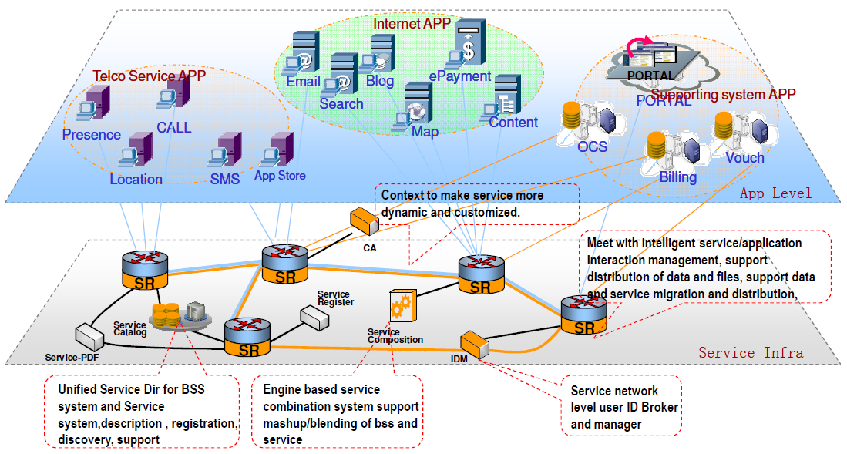
Figure 3: Service Cloud

2.11.2 Support SaaS model
CSeON shall be able to deliver services like mashup applications as Software as a Service based on pay per use model.

2.11.3 Compute as a Service
CSeON shall be able to utilize the Public/Private cloud for processing complex service tasks. Ex. personalization

2.11.4 Storage as a Service
CSeON shall be able to utilize the public/private storage cloud on demand to meet the high scale data storage and also be able to support the real-time and non-real time data/content access requirements. This public storage requirement is only for non-sensitive data/content. All user related information should be stored in a private cloud operated upon by the service provider.

3. Gap Analysis
Many industry standard bodies have focused on studying the area of CSeON which includes ATIS SON, 3GPP, ETSI-TISPAN, ITU-T SG13, OASIS, OMA, SNIA, TMF, OGF, OMG, IEEE P1903 (NGSON), GSMA and others.

The gaps identified are in the following topics:
3.1 Service Delivery
Common Service Enabler Description
Standardization of inter-domain service handoff
Service Enabler Publishing
Standardization of SON in transport layer
3.2 Service Syndication
Standardization of end-user service syndication
User domain Service Enablers
<Assessment of user domain standard gaps>
3.3 Service Creation
<Assessment of Service Creation standards gaps>
3.4 Inter-domain User Profile Data Acquisition
Standardization of User Profile Data Acquisition (Crossdomain)
3.5 Service Quality Management – Standardization
3.6 3rd Party Interfaces
Consistency of 3rd Party interfaces
Parlay architecture for attribute sharing and identity management
Device Independent Mobile Framework
3.7 Data Models
Common Data Model requirements
Common Name Space Requirement
3.8 IT Infrastructure, Virtualization, Storage
Service Oriented Infrastructure Standardization
3.9 OSS/BSS
Coordinated exchange of data across organization boundaries
Common repository of product data catalogues
Common repository of metadata
Customer-centric profiles and service sessions
Flexible billing and charging systems standards
Federated Information Architecture for Ontology Definition of SoA
Service contract and SoA protocols Standards
3.10 Policy
Assessment of redundant or divergent standards
Common Policy Reference Model, Syntax and Semantics
Policy Detection Methods
Network detection of Application QoS requirements
Policy Interfaces and Mapping
The most recently known standard available for CSeON Architecture was published by IEEE P1903 project called as IEEE Standard for the Functional Architecture of Next Generation Service Overlay Networks.

4. CSeON Framework
Figure 1 shows an example of how new service providers can take advantage of a CSeON framework by using the underlying APIs and protocols.

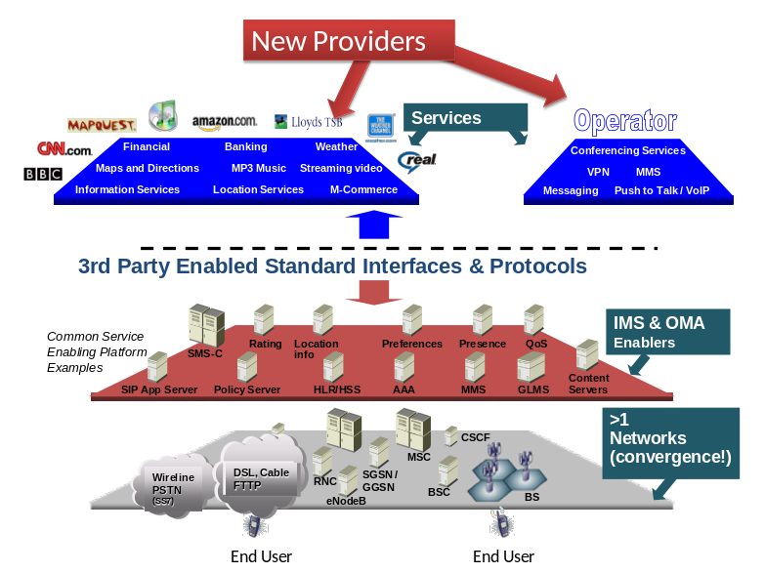
Figure 4: Service delivery platform based on CSeON

A service oriented network enables the new providers to offer value added services while using the existing underlying services. It shows a multi-tiered architecture. At the lowest layer there are multiple types of networks providing a layer of network convergence. On the top of network layer there is common service platform layer. This layer consists of services as offered by IMS (IP Multimedia Services) and OMA (Open Mobile Alliances). Current operators and new service providers offer new variety of services using the third party APIs and protocols. CSeON WG is defining these APIs and protocols that will allow the existing service providers and the new ones to offer a variety of services.
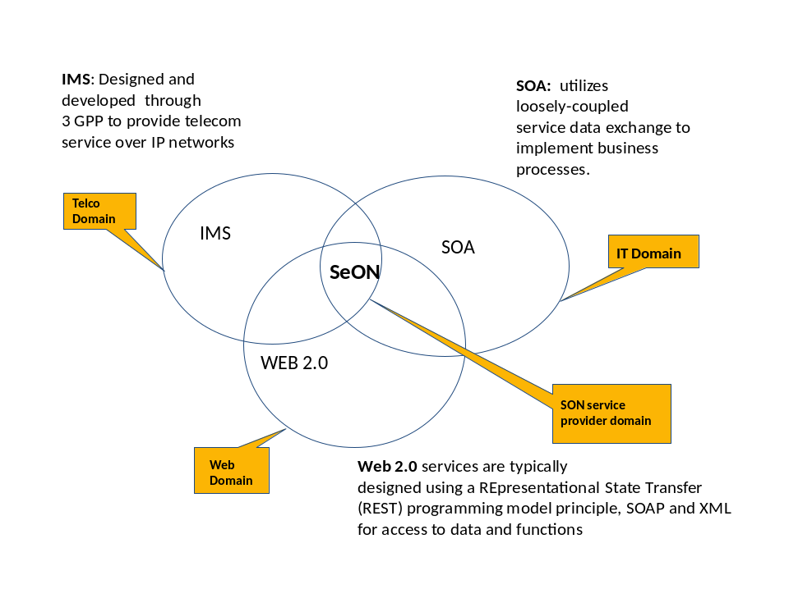
Figure 5: CSeON Domain

Figure 2 shows how CSeON domain takes the best of three domains such as IMS (IP Multimedia Subsystem), SOA (Service Oriented Architecture) and WEB 2.0. While IMS is suitable for Telco, WEB 2.0 is most suited for Web domain. On the other hand, SOA is most suited for IT domain.

5. Architectural Options
5.1 IEEE P1903 (NGSON)
The IEEE NGSON architecture bridges the CSeON gaps between Application and services and the Underlying networks by creating 2 sets of functions viz., service related functions and transport related functions.
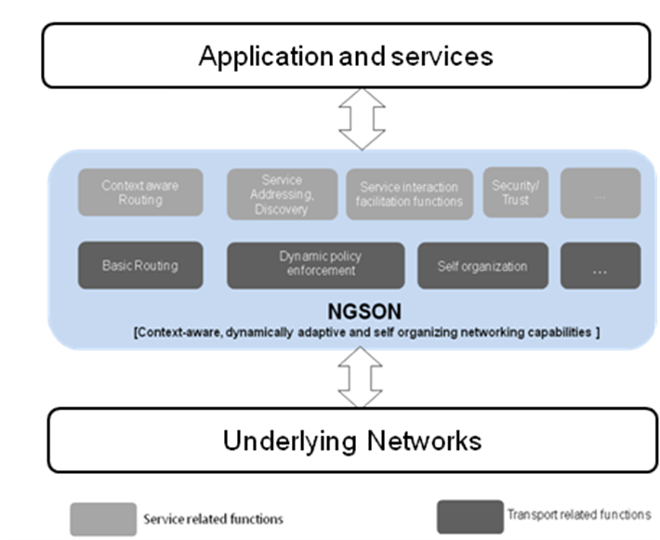
Figure 6: NGSON Framework

6. CONCLUSIONS
This document has been prepared as input to the global CSeON standards initiatives. GISFI fully supports a consistent set of global CSeON standards. This document contains CSeON target objectives and features. Phased implementable standards will be developed for these target objectives and features. The CSeON-WG will continue to clarify the priorities (i.e., short-term, medium-term, long-term).
A key motivation for the CSeON is centered on the variety of new, value-added, IP centric services and applications. An equally important motivation is reduced CAPEX and OPEX through more efficient delivery of services.
GISFI will continue to work with groups such as TISPAN, 3GPP, IEEE and ITU-T to develop a consistent set of CSeON standards that meet the needs of GISFI members. To comply with unique Indian requirements/ standards, GISFI plans to share with all internal technical committees and others where appropriate.

7. ACRONYMS & ABBREVIATIONS
3G | 3rd Generation
3GPP | 3rd Generation Partnership Project
3GPP2 | 3rd Generation Partnership Project #2
AAA | Access Authorization and Authentication
ARIB | Association of Radio Industries and Businesses
ASP | Application Service Provider
ATIS | Alliance for Telecommunications Industry Solutions
BSO | Basic Service Operators
CAPEX | Capital Expense
CDMA | Code Division Multiple Access
CP | Customer Premises
CPE | Customer Premises Equipment
CMSP | Cellular Mobile Service Providers
DCMA | Digital Millennium Copyright Act
DHCP | Dynamic Host Configuration Protocol
DNS | Domain Name System
DoS | Denial of Service
DRM | Digital Rights Management
DSL | Digital Subscriber Line
EMS | Emergency Medical Service
ETSI | European Telecommunications Standards Institute
GISFI | The Global ICT Standardization Forum for India
HTTP | HyperText Transfer Protocol
IEEE | Institute of Electrical and Electronics Engineers
IETF | Internet Engineering Task Force
IM | Instant Messaging
IMS | IP (Internet Protocol) Multimedia Subsystem
IP | Internet Protocol
IP-CAN | IP Connectivity Access Networks
IPsec | Internet Protocol Security
ISP | Internet Service Provider
IT | Information Technology
ITU-T | International Telecommunications Union - Telecommunications Standardization Sector
IVR | Interactive Voice Response
LAN | Local Area Network
LBS | Location Based Service
LE | Law Enforcement
MAN | Metropolitan Area Networks
MOS | Mean Opinion Score
MVNO | Mobile Virtual Network Operation
NGOSS | Next Generation OSS
NGSP | Next Generation Service Provider
NGSON | Next Generation Service Overlay Network
NI | Network Interface
NSP | Network Service Provider
OAM | Operations, Administration ,and Maintenance
or OAM&P | Operations, Administration, Maintenance, & Provisioning
OPEX | Operational Expense
OSA | Operator Service Agreements
OSS | Operations Support System
PBX | Private Branch Exchange
PC | Personal Computer
PDA | Personal Digital Assistant
PLMN | Public Land Mobile Network
POTS | Plain Old Telephone Service
PSTN | Public Switched Telephone Network
PTSC | Packet Technologies and Systems Committee
QoS | Quality of Service
RFC | Request For Comment
CSeON | Cloud & Service Oriented Network
SDE | Service Delivery Environment
SDO | Standards Development Organization
SG | Study Group
SIM | Subscriber Identify Module
SIP | Session Initiation Protocol
SLA | Service Level Agreement
SMS | Short Message Service
SP | Service Provider
SS7 | Signaling System 7
TCP | Transmission Control Protocol
Telco | Telecommunications Company
TIPHON | Telecommunications and Internet Protocol Harmonization Over Networks
TISPAN | Telecommunications and Internet Converged Services & Protocol for Advance Networks
TOPS | Technology and Operations (Council)
TRAI | Telecom Regulatory Authority of India
UDP | User Datagram Protocol
VoIP | Voice over IP (Internet Protocol)
VPN | Virtual Private Network
VSO | Virtual Service Operations
WAE | Wide Area Ethernet
WAN | Wide Area Network
WiFi | Wireless Fidelity
WiMax | Worldwide Interoperability for Microwave Access
WLAN | Wireless LAN

